9. Assessment of the Flathead Sole-Bering Flounder Stock Complex Stock in the Bering Sea and Aleutian Islands

Maia S. Kapur, and Lee Cronin-Fine

November 2024

This report may be cited as: Kapur, M.S., Cronin-Fine, L. 2024. Assessment of the flathead sole-Bering flounder stock complex in the Bering Sea and Aleutian Islands. North Pacific Fishery Management Council, Anchorage, AK. Available from <https://www.npfmc.org/library/safe-reports/>

# Executive Summary

## Summary of Changes in Assessment Inputs

*Changes in the input data*:

* bottom trawl survey biomass for years 2021-2024;
* survey length composition data for years 2021-2024;
* conditional age-at-length data from the bottom trawl survey for years 2021-2023;
* marginal fishery length compositions from 2020-2023 (though only 2022 and 2023 are included in the likelihood); and
* marginal fishery age compositions from 2020 and 2021. The Age and Growth program was not able to provide marginal fishery age compositions for more recent years due to staffing shortages;
* replacement of the input sample sizes for survey compositional data with values obtained from the surveyISS package version 1.0.0 (previously, the number of hauls or the nominal sample size [number of otoliths] were used for marginal lengths and coniditional age-at-length data, respectively).

*Changes in the assessment methodology*: The assessment methodology is the same as the most recent full assessment conducted in 2020 (Monnahan and Haehn 2020), with the small change that the projection model was updated to the latest version of spm and the recruitment time series passed to the projections now begins in 1977 for consistency with other assessment workflows. (Previously the entire time series from 1964 onwards was used).

## Summary of Results

For the 2025 fishery, we recommend the maximum allowable ABC of 83,807 t. This ABC is a 22.9% increase from the ABC recommended by last year’s model for 2025 of 68,203 t. The increase is attributed to several years of elevated survey biomass, and that the projection model routine has been updated to use recruitment values from 1977-present to be consistent with programmatic approaches; these recruitment estimates are on average about 14% higher than the full time series (1964-present), which was previously used.

|  | As estimated or *specified last* year for: | | As estimated or *recommended this* year for: | |
| --- | --- | --- | --- | --- |
| **Quantity/Status** | 2024 | 2025 | 2025* | 2026* |
| M (natural mortality) | 0.2 | 0.2 | 0.2 | 0.2 |
| Tier | 3a | 3a | 3a | 3a |
| Projected total (age 2+) biomass (t) | 609,488 | 608,230 | 801,418 | 832,021 |
| Projected female spawning biomass (t) | 165,629 | 169,452 | 204,323 | 220,515 |
| B100% | 203,658 | 203,658 | 243,288 | 243,288 |
| B40% | 81,463 | 81,463 | 97,315 | 97,315 |
| B35% | 71,280 | 71,280 | 85,150 | 85,150 |
| FOFL | 0.46 | 0.46 | 0.49 | 0.49 |
| *max*FABC | 0.37 | 0.37 | 0.40 | 0.40 |
| FABC | 0.37 | 0.37 | 0.40 | 0.40 |
| OFL (t) | 81,605 | 82,699 | **101,621** | 106,283 |
| *max*ABC (t) | 67,289 | 68,203 | 83,807 | 87,700 |
| ABC (t) | 67,289 | 68,203 | **83,807** | 87,700 |
|  | As determined *last* year for: | | As determined *this* year for: | |
| **Status** | 2023 | 2024 | 2024 | 2025 |
| Overfishing | No | n/a | No | n/a |
| Overfished | n/a | No | n/a | No |
| Approaching overfished | n/a | No | n/a | No |
| *Projections are based on an estimated catch of 11,125 t for 2024 and estimates of 11,148 t and 11,148 t used in place of maximum permissible ABC for 2025 and 2026. | | | | |

## Responses to SSC and Plan Team Comments on Assessments in General

“The SSC requests that all authors fill out the risk table in 2019…” (SSC December 2018)

We provide a risk table in the Harvest Recommendations section. After completing this exercise, we do not recommend ABC be reduced below maximum permissible ABC.

## Responses to SSC and Plan Team Comments Specific to this Assessment

1. Continue exploration of environmental drivers of FHS stock distribution and behavior, as average summer bottom temperature appears inadequate (SSC, December 2018)

This is out of scope for the present assessment, but might be addressed for the next Full assessment (2028).

2. Investigate data from the NBS for Bering Flounder (SSC, December 2018)

This is out of scope for the present assessment, but might be addressed for the next Full assessment (2028).

3. Consider separately modeling the pelagic trawl fishery with its own selectivity curve (Plan Team, November 2020)

This is out of scope for the present assessment, but might be addressed for the next Full assessment (2028). The pelagic trawl fishery accounts for up to 30% of landings annually and data from that fleet are not included in fishery age nor length compositions.

# Introduction

Operational Update: The reader is referred to the full operational stock assessment (Monnahan and Haehn 2020) for the description of Flathead sole-Bering flounder biology and life history.

# Fishery

Operational Update: The reader is referred to the last full operational stock assessment assessment (Monnahan and Haehn 2020) for the full description of Flathead sole-Bering flounder fishery history, fishery effort and CPUE, and information regarding discarding.

Table 9.1 shows a time series of total catch, ABC, TAC, OFL and relevant management measures.

# Data

Operational Update: The data description for Flathead sole-Bering flounder has been truncated to highlight relevant updates or changes made for this cycle. The reader is referred to the last full assessment (Monnahan and Haehn 2020) for the entirety of this section.

The following table summarizes the data used for this assessment.

| **Source** | **Data** | **Species** | **Years** |
| --- | --- | --- | --- |
| NMFS Aleutian Islands Groundfish Trawl Survey | Survey biomass (linear regression used to combine BS shelf survey estimates with AI survey estimates for a single survey biomass index) | Flathead only; no Bering flounder were caught in the Aleutian Islands | 1983, 1986, 1991-2000 (triennial), 2002-2006 (biennial), 2010-2022 (biennial) |
| NMFS Bering Sea Shelf Groundfish Survey (standard survey area only; excludes survey strata 70, 81, 82, 90, 140, 150, and 160) | Survey biomass (linear regression used to combine BS shelf survey estimates with AI survey estimates for a single survey biomass index) | Flathead sole and Bering flounder combined | 1982-2019, 2021-2024 |
| Conditional age-at-length composition | Flathead sole only | 1982, 1985, 1992-1995, 1999-2019, 2021-2023 |
| Marginal length composition | Flathead sole only | 1982-2019, 2021-2024 |
| U.S. trawl fisheries | Catch (pelagic and non-pelagic trawl in the Bering Sea and Aleutian Islands; a very small amount of catch is taken with hook and line and is included in the total catch biomass) | Flathead sole and Bering flounder combined | 1963-2024 (final year is estimated) |
| Marginal age composition (Bering Sea only; non-pelagic trawl only)* | Flathead sole only | 2000, 2001, 2004-2007,2009-2021 |
| Marginal length composition (Bering Sea only; non-pelagic trawl only)* | Flathead sole only | 1977-1999, 2002-2003, 2008, 2020-2023 |
| Foreign trawl fisheries in the BSAI | Catch (Bering Sea and Aleutian Islands; trawl) | Flathead sole and Bering flounder combined | 1964-1987 |
| *To avoid double-counting data used to estimate parameters in the assessment model, the size composition data were excluded in the model optimization when the age composition data from the same year were available. Thus, only the flathead sole fishery size compositions for 1977-1999, 2002-2003, 2008, 2022 and 2023 were included. | | | |

## Fishery

Catches as used in the model are shown in Table 9.1; discards are not used in the model. Fishery-dependent compositional data (catch-at-length and catch-at-age, and associated input sample sizes) are shown in Tables 9.2 through 9.5. The model uses an estimate of 2024 catch to be consistent with the projection routine.

## Survey

Survey biomass estimates and associated sampling variability (annual CVs) are shown in Table 9.6. Survey length compositional data are shown in Tables 9.7 and 9.8. Survey conditional age-at-length data is prohibitively large to present in this document; readers may access these data electronically [here](https://github.com/afsc-assessments/bsai-fhs/blob/bafa7658d31e0b99fe11d626a58e1c01807c69ee/2024/mgmt/18.2c_2024/2020_BSAI_FHS.dat#L277).

This assessment updated the input sample sizes for all survey compositional datasets (marginal lengths and conditional ages-at-length [CAAL], as well as those for marginal ages which are not included in the joint likelihood). The previous approach used the number of hauls as the input sample size for marginal lengths, and the nominal number of read otoliths as the input sample size for CAAL data.

# Analytical approach

Operational Update: The data description for Flathead sole-Bering flounder has been truncated to highlight relevant details and changes made for this cycle. The reader is referred to the last full assessment (Monnahan and Haehn 2020) for the entirety of this section.

## General Model Structure

The model structure used for this Operational Update is unchanged from 2020. The BSAI flathead sole assessment is a two-sex, age-structured statistical catch-at-age model in Stock Synthesis (SS3, Methot and Wetzel (2013)). The assessment model was transitioned from version 3.30.16 to the latest version of SS3 available as of January 2024 (3.30.22). No detectable changes in derived quantities nor likelihoods occurred as a result of this software change. After all data were added to the model, we updated the Francis (2011) compositional data weights to account for the effects on effective sample size of potential time-varying processes that were not explicitly taken into account in the model structure. For more details, see externally-linked document [here](https://afsc-assessments.github.io/bsai-fhs/2024_bridging_analysis.html).

## Description of Base Model

perational Update: The configuration matches the accepted model from 2020, with updated data. A full revision to the modeling framework is anticipated in the next cycle (2028). There are no alternative models presented here.

A total of 112 parameters were estimated inside the assessment model, 62 of which were annual recruitment deviations. A description of the treatment of all model parameters (fixed and estimated), their maximum likelihood estimates, and uncertainty intervals are provided in Table 9.9.

## Parameters Estimated Outside the Assessment Model

The survey catchability, time- and age-invariant natural mortality for females and males, variability of recruitment ($σ_{r}$), the parameters of the maturity ogive, the ageing error matrix, and the weight-length relationship were estimated outside the assessment model.

### Input Sample Sizes for Survey Compositions

Following updated research by AFSC staff, we implemented the surveyISS R package with 500 bootstrap samples to estimate new input sample sizes for each of these data sets, or the average estimated input sample size for nearby length bins and years when the method returned no value. Using the package resulted in values for the marginal length compositions 3-4 times higher those previously used; this is expected given that there are generally more samples than there are hauls, and length observations are less variable across hauls than they are across ages. After updating the input sample sizes, we algorithmically re-tuned the Francis data weights and compared the derived quantities and parameter estimates between models. The impact on all values was minimal; a detailed description of this bridging exercise and relevant figures are available [here](https://afsc-assessments.github.io/bsai-fhs/2024_bridging_analysis.html#comparison-with-updated-surveyiss-sample-sizes).

### Survey Catchability

The survey catchability parameter was set to 1.0.

### Natural Mortality

The natural mortality rates were set to 0.2 for both sexes, and $σ_{r}$ was equal to 0.5, consistent with previous assessments.

### Maturity Ogive

The maturity ogive for flathead sole followed an age-based logistic curve where age at 50% maturity was 9.7 and age at 95% maturity was 12.8 (Figure 9.19).

### Ageing error matrix

The ageing error matrix was taken directly from the Stock Synthesis model used in assessments prior to 2004 (Spencer and Wilderbuer. 2004).

### Length-Weight Relationship

The same length–weight relationship used in 2020, of the form $W=aL^{b}$ was estimated by fitting to survey data from 1982-2016 for males and females combined, with parameter estimates a = 0.00298 and b = 3.327 (weight in g, length in cm).

## Parameters Estimated Inside the Assessment Model

### Recruitment

The log of unfished recruitment ($R_{0}$), log-scale recruitment deviations for an early period 1964-1972 and a main period (1973-2020) were estimated. A 1:1 sex ratio is assumed. The age-0 recruitment was fixed to equal mean recruitment for the most recent four years because too few flathead sole are observed at ages 0-3 to estimate recruitment reliably.

### Growth

Sex-specific growth parameters ($L_{amax=21+}$, $L_{amin=3}$, $k$, CV of length-at-age 3, CV of length-at-age 21+) were estimated inside the assessment model.

### Selectivity and fishing mortality

Survey selectivity parameters were estimated using age-based, sex-specific, asymptotic curves that were time-invariant. The double-normal curve was used to easily allow previous and future explorations of alternative survey selectivity forms, but as in 2020 was constrained to mimic a logistic shape because there was no evidence for dome-shaped survey selectivity.

Fishery selectivity parameters for logistic, length-based, sex-specific curves were estimated (the parameters for each curve were the length at 50% selectivity to the fishery and slope of the selectivity curve). Separate fishery selectivity curves were estimated for two distinct time periods (1964-1987 and 1988-present).

Finally, annual fishing mortality rates were estimated (1964-2024).

# Selected Model Results

Operational Update: This section has been condensed to follow the newest guidelines for “Operational Update Assessments” to the best of the Authors’ ability. A minimal set of figures and tables are provided here; links to electronic files for supplementary data (e.g., numbers-at-age from the base model) are included in-text.

The model used in this assessment is the same as the model accepted in 2020 (Model 18.2c (2020)) with updated data and parameter priors. Model 18.2c (2020) with data updated through 2024 (presented as Model 18.2c (2024)) generally results in reasonable fits to the data (see Figures 9.3 through 9.16), estimates biologically plausible parameters (see Table 9.9), and produces consistent patterns in abundance compared to previous assessments (Figure 9.17).

## Time Series Results

*Definitions:*

* **Spawning biomass** is the estimated weight of mature females, in t.
* **Total biomass** is the estimated weight of all fish ages 3 and greater, in t.
* **Recruitment** is measured as the number of age-zero individuals.
* **Fishing mortality** is the mortality at the age the fishery has fully selected the fish.

Key results have been summarized in Table 9.10. Model predictions generally fit the data well (Figures 9.2 through 9.3). A comma-separated electronic file containing the estimated numbers-at-age is available [here](https://github.com/afsc-assessments/bsai-fhs/blob/main/2024/mgmt/18.2c_2024/natage.csv).

### Biomass

Spawning biomass was at a low in 1983 of 78,059.4 t, reached a peak in 1998 of 223,014 t, slowly decreased through 2020 and recently increased to a current spawning biomass of 185,493 t in 2024 (Figure 9.17). These trends correspond to a period of high recruitment from 1980-1990, a period of low recruitment occurred from 2004-2010 (Figure 9.18) and increasing survey observations since 2015 (Figure 9.3). The survey data are fit well throughout the time series.

### Fishing Mortality

Historical apical fishing mortality was between 0.009 and 0.06 for the historical period of foreign fleets and the joint venture fishery. The estimates of uncertainty in fishing mortality during this period are artificially small due to the absence of a stock-recruitment relationship. Fishing mortality reached a peak in 1990 at 0.126, and remained between 0.065 and 0.104 in the 1990s and early 2000s. Fishing mortality reached another peak of approximately 0.131 in 2008 and has declined since then (Figure 9.20).

### Selectivity

Figure 9.19 shows the estimated length-based fishery selectivity curves and estimated age-based survey selectivity curves for Model 18.2c (2024). The curves suggest that males are caught at smaller lengths than females for both fleets.

The time-blocked fishery survey selectivity curves Model 18.2c (2024) indicate selection of smaller fish of both sexes in the early period (1964-1987) versus the later period (1988-present). The early period is characterized by a paucity of compositional data (Figure 9.1). The survey data (beginning in 1982) do not suggest that length-at-age was distinct across these time periods. We also do not suspect that the growth curves of fish captured by the fishery vary through time, as the aggregate fits to fishery length data (Figure 9.8) are satisfactory. This is despite the fact that data from many of those years were not included in the joint likelihood; only the survey data was used to inform growth parameters and variability in growth in the model.

### Recruitment

Recruitment (as measured by age-0 fish) is moderately variable (Figure 9.17). A period of high recruitments occurred from 1980-1990, and a period low recruitments occurred from 2004-2010 (Figure 9.18). The age-0 recruitment was fixed to equal mean recruitment for the most recent four years because too few flathead sole are observed at ages 0-3 to estimate recruitment reliably for recent years.

Flathead sole do not seem to exhibit a stock-recruitment relationship because large recruitment has occurred during periods of high and low biomass (Figure 9.17 and Table 9.10).Model 18.2c (2024) does not specify an explicit stock-recruitment relationship. The average annual recruitment (in numbers) spawned after 1976 is estimated to be 1.024 million.

## Model Evaluation

### Comparison to Previous Model

A comparison of key derived quantities from the base model and the most recent full assessment is shown in Figure 9.17. Parameter estimates, fits to the data and likelihood values have remained similar to Model 18.2c (2020).

As has resulted in the BSAI FHS models since 2012 (Monnahan and Haehn (2020), McGilliard (2016), McGilliard (2014), and Stockhausen (2012)), the estimated survey length composition often expects larger proportions of fish in the 20-30 cm range than has been observed. Several hypotheses have been explored through additional model runs about why this residual pattern occurred (McGilliard (2016)) by testing more flexible selectivity patterns, a four-parameter growth curve, more complexity in CV in length at age, alternative and data weighting schemes, yet none of these tests improved the residual pattern nor fit to the data. One last, untested hypothesis is that the data do not fully characterize the variability in length at age for this stock. In other words, the distribution of lengths for the fish with otoliths collected does not match the length distribution of all fish sampled. This hypothesis was not explored here but could be in future assessments.

Similarly, overall fits to fishery age and length composition data were reasonable, but not perfect Figures 9.4 through 9.11). The yearly distributions of ages varied from year to year, suggesting that perhaps a larger sample of ages from the fishery each year would improve our knowledge of the distribution of ages caught by the fishery. One very large Pearson residual occurred in fits to male fishery length-composition data in 1983 (Figure 9.9), which might be driven by a plus-group observation so large as to be a data entry error, and disappears upon calculation of one-step-ahead residuals (Figure 9.11). The aggregate fits to the fishery length composition data suggest that the fishery caught more 45-60cm males than were expected (Figure 9.4), but this is mostly driven by misfits before 1989; we would not expect the fits to this data source to be as good given the low Francis weight applied to these data in the joint likelihood.

### Residual Analysis and Convergence Criteria

The model achieved convergence as defined by an invertible Hessian matrix and a low maximum gradient component (less than 1e-4) which was achieved using the hess_step function in ADMB. Time-series plots of observed and predicted values (e.g. Figure 9.3), and the time-series of recruitment deviations (Figure 9.18) did not suggest unusual residual patterns, or different behavior than in previous assessments. The uncertainty around parameter estimates and related derived quantities were in line with previous models (Tables 9.9 and 9.10).

### Parameter Estimates and Parameter Uncertainty

Table 9.9 shows the maximum likelihood estimate (MLE) of key parameters in Model 18.2c (2024) with corresponding 95% credible intervals given by the asymptotic uncertainty. Time series of deviation parameters (fishing mortality rates $F$ and recruitment deviations from 1964-2024 are shown in Figures 9.17 and 9.18, respectively.

## Harvest recommendations

Operational Update: This section been truncated to provide minimal background and highlight relevant updates or changes made for this cycle. The reader is referred to the last full assessment (Monnahan and Haehn 2020) for the entirety of this section, including details on the projection approach.

### Amendment 56 Reference Points

This stock complex is managed under Tier 3a of Amendment 56. The following table shows the reference points calculated for the 2024 assessment.

| Reference Point | Description | Value |
| --- | --- | --- |
| $$B_{100\%}$$ | The equilibrium spawning biomass that would be obtained in the absence of fishing | 243,288 t |
| $$B_{40\%}$$ | 40% of the equilibrium spawning biomass that would be obtained in the absence of fishing | 97,315 t |
| $$B_{35\%}$$ | 35% of the equilibrium spawning biomass that would be obtained in the absence of fishing | 85,150.5 t |
| $$F_{40\%}$$ | The fishing mortality rate that reduces the equilibrium level of spawning per recruit to 40% of the level that would be obtained in the absence of fishing | 0.4 |
| ABC | Yield at $F_{40\%}$ in 2025 | 83,807 t |
| $$F_{35\%}$$ | The fishing mortality rate that reduces the equilibrium level of spawning per recruit to 35% of the level that would be obtained in the absence of fishing | 0.49 |
| OFL | Yield at $F_{35\%}$ in 2025 | 101,621 t |

### Specification of OFL and Maximum Permissible ABC

#### Standard Harvest Scenarios (Harvest Projections)

We used the spm projection software, downloaded and compiled on 04 April 2024.

A standard set of projections is required for each stock managed under Tier 3 of Amendment 56. Five of the seven standard scenarios support the alternative harvest strategies analyzed in the Alaska Groundfish Harvest Specifications Final Environmental Impact Statement. They are as follows (“max $F_{ABC}$” refers to the maximum permissible value of $F_{ABC}$ under Amendment 56):

* *Scenario 1*: In all future years, $F$ is set equal to max $F_{ABC}$ (Rationale: Historically, TAC has been constrained by ABC, so this scenario provides a likely upper limit on future TACs.)
* *Scenario 2*: The exact calculation of these values is shown below.
* *Scenario 3*: In all future years, $F$ is set equal to 50% of max $F_{ABC}$. (Rationale: This scenario provides a lower bound on $F_{ABC}$ that still allows future harvest rates to be adjusted downward when stocks fall below reference levels.)
* *Scenario 4*: In all future years, $F$ is set equal to the 2018-2022 average F. (Rationale: For some stocks, TAC can be well below ABC, and recent average $F$ may provide a better indicator of FTAC than $F_{ABC}$.)
* *Scenario 5*: In all future years, $F$ is set equal to zero. (Rationale: In extreme cases, TAC may be set at a level close to zero.)

Two other scenarios are needed to satisfy the MSFCMA’s requirement to determine whether a stock is currently in an overfished condition or is approaching an overfished condition. These two scenarios are as follows (for Tier 3 stocks, the MSY level is defined as $B_{35\%}$):

* *Scenario 6*: In all future years, $F$ is set equal to $F_{OFL}$. (Rationale: This scenario determines whether a stock is overfished. If the stock is expected to be above 1) above its MSY level in 2024 or 2) above ½ of its MSY level in 2024 and above its MSY level in 2034 under this scenario, then the stock is not overfished.) While Scenario 6 gives the best estimate of OFL for 2024, it does not provide the best estimate of OFL for 2025, because the mean 2024 catch under Scenario 6 is predicated on the 2024 catch being equal to the 2024 OFL, whereas the actual 2024 catch will likely be less than the 2024 OFL. The executive summary contains the appropriate one- and two-year ahead projections for both ABC and OFL.
* *Scenario 7*: In 2025 and 2026, $F$ is set equal to max $F_{ABC}$, and in all subsequent years $F$ is set equal to $F_{OFL}$. (Rationale: This scenario determines whether a stock is approaching an overfished condition. If the stock is 1) above its MSY level in 2026 or 2) above 1/2 of its *MSY* level in 2026 and expected to be above its MSY level in 2036 under this scenario, then the stock is not approaching an overfished condition.)

#### How Future Catches are Specified for Scenario 2 (Author’s F)

The method for specifying catches in years 2024 to 2026 has not changed from the 2020 assessment.

For Scenario 2 (*Author’s F*); we use pre-specified catches to increase accuracy of short-term projections in fisheries where the catch is usually less than the ABC. We specify 2024 catches as the most current observed catches plus the typical (5-year average) landings through the present date through the end of the calendar year, and the catches for years 2025 and 2026 as the average catch from 2019 to 2023, which is 11,148 t.

Projected catches, spawning biomass, and fishing mortality rates corresponding to the alternative harvest scenarios over a 13-year period are shown in Tables 9-11 through 9-13.

## Risk Table and ABC recommendation

The risk table scoring for BSAI FHS has not changed since 2020.

| *Assessment-related considerations* | *Population dynamics considerations* | *Environmental/ecosystem considerations* | *Fishery Performance* |
| --- | --- | --- | --- |
| Level 1: No concern | Level 1: No concern | Level 1: No concern | Level 1: No concern |

An abridged summary of the considerations that led to this determination for each category follows.

### Assessment considerations

Overall, the model fits all the data sets very well. Both the survey index, and survey and fishery composition data show no concerning patterns. All parameters were well estimated, without any convergence issues. Adding the new data had a minimal impact on estimated parameters and management quantities, corroborating the general stability of the model found in previous assessments. *We therefore conclude there are no increased concerns and set this consideration at level 1.*

### Population dynamics considerations

The spawning stock biomass has been above target for the entire time period for which there are data. It is projected to increase into the near future (based on the Scenario 4 projection above) as there was a series of above-average recruitments from 2015-2020 that continue to mature. This increase is already borne out in the estimated age 3+ biomass (Figure 9-17) and observed index (Figure 9-3), both of which show a general increase since 2015. *Since we have no increased concerns we set the concern level to 1.*

### Environmental/Ecosystem considerations

*Summary for Environmental/Ecosystem considerations*: This is a summary of details provided by the

**Environment**: The EBS shelf experienced oceanographic conditions that were largely average based on historical time series of multiple metrics over the past year (August 2023 - August 2024). The cold pool was average in extent over the shelf. Winds favored offshore Ekman transport from March through May that may have hindered transport to suitable nearshore nursery habitat. **Prey**: Indicators of prey availability suggest sufficient prey may have been available for FHS-Bering flounder. Competition: Trends in potential competitors indicate competition for prey resources remains low in 2024. **Predation**: Trends in competitors indicate potentially increased predation pressure for FHS-Bering flounder.

*Together, the most recent data available suggest an ecosystem risk Level 1 – Normal: “No apparent ecosystem concerns related to biological status (e.g., environment, prey, competition, predation), or minor concerns with uncertain impacts on the stock.”*

### Fishery performance

There is no ESP for this stock complex, but we note that the fishery has consistently caught only a small fraction of the ABC (averaging less than 20% over the last five years). We did not examine CPUE trends nor spatial patterns of fishing. There are no changes in the duration of fishing openings. *Altogether, we see no cause for concern and give this consideration a level 1 as well.*

### Risk Table Summary and ABC recommendation

*Since we rated all four considerations at level 1, we do not believe a reduction from $max_{ABC}$ is warranted.*

## Status Determination

The status definitions under the MSFCMA have been truncated from this report.

### Overfishing

The official catch estimate for the most recent complete year (2023) is 8,988 t. This is less than the 2023 OFL of 48,161 t. *The stock is not subject to overfishing.*

### Overfished (Harvest Scenario 6)

The minimum stock size threshold (MSST) for BSAI FHS is given by $B_{35\%}$ which is 85,150 in 2024. The estimated stock spawning biomass in 2024 is more than double the MSST at 204,323. *The stock is not overfished*.

### Approaching Overfished (Harvest Scenario 7)

The mean estimated stock spawning biomass in 2037 under Harvest Scenario 7 is greater than $B_{35\%}$ (Table 9-12). *The stock is not approaching an overfished state*.

The $F$ using Model 18.2c (2024) that would have produced a catch for 2023 equal to the OFL specified in 2023 for 2023 (48,161) was 0.333.

# Ecosystem Considerations

Operational Update: The Ecosystem Considerations for BSAI FHS are unchanged. The reader is referred to the last full assessment (Monnahan and Haehn 2020) for the entirety of this section. The Ecosystem component of the Risk Table provides the most updated information for this stock.

# Data Gaps and Research Priorities

Operational Update: The reader is referred to the last full stock assessment (Monnahan and Haehn 2020) for the entirety of the BSAI FHS Data Gaps and Research Priorities section. The sole update to this section concerns the genetic distinction between Bering flounder and Flathead sole:

A collection of flathead sole from the Aleutian Islands (n=24) was analyzed using low coverage whole genome sequencing along with collections of yellowfin sole (*Limanda aspera*) and Bering flounder (*Hippoglossoides robustus*) (Figure 9.21). Results confirmed that flathead sole is genetically distinct from Bering flounder, which is significant given that they are identical at cytochrome b (Kartavtsev YP (2008)). A principal components analysis (Figure 9.22) shows clear separation among flathead sole, Bering flounder, and yellowfin sole, and the differences are all relatively similar; no two species appear more similar than others. This is significant because previous analyses based on cytochrome b, morphometric, and protein data have suggested synonymization of Hippoglossoides robustus under H. elassodon. (Hardy and Mah (2011)). Further analysis is needed to examine whether there is genetic diversity among flathead sole from the Aleutian Islands vs. eastern Bering Sea. We recommend that a collection of flathead sole (n=25) from the eastern Bering Sea survey be sequenced in 2025.

# Acknowledgements

The authors would like to acknowledge the data collection and processing efforts of the survey and age and growth groups, particularly Derek Chamberlain and his staff for providing recent age data ahead of schedule. We acknowledge Ingrid Spies for providing a write-up of the latest genetic analyses for this stock, and Elizabeth Siddon for her contribution to the Ecosystem component of the Risk table.

# References

Hardy, C., S. M. and Mah, C. (2011) Biodiversity and phylogeography of arctic marine fauna: Insights from molecular tools. *Marine Biodiversity* 41, 195–210.

Kartavtsev YP, L.J., Park TJ (2008) Hylogenetic inferences introduced on cytochrome b gene sequence data for six flatfish species (teleostei, pleuronectidae) and species synonymy between representatives of genera pseuopleuronectes and hippoglossoides from far eastern seas. *Russian Journal of Genetics* 44, 451–458.

McGilliard, C. (2014) *Assessment of the flathead sole stock in the gulf of alaska*. North Pacific Fish. Manag. Counc. 605 W. 4th Ave. Suite 306 Anchorage, AK 99301.

McGilliard, C. (2016) *Assessment of the flathead sole-bering flounder stock in the bering sea and aleutian islands*. North Pacific Fish. Manag. Counc. 605 W. 4th Ave. Suite 306 Anchorage, AK 99301.

Methot, R.D. and Wetzel, C.R. (2013) [Stock synthesis: A biological and statistical framework for fish stock assessment and fishery management](https://doi.org/10.1016/j.fishres.2012.10.012). *Fisheries Research* 142, 86–99.

Monnahan, C. and Haehn, R. (2020) Assessment of the flathead sole-Bering flounder stock complex in the Bering Sea and Aleutian Islands. *Stock assessment and fishery evaluation report for the groundfish resources of the Gulf of Alaska as projected for 2020*, 1–91.

Spencer, W., P. D. and Wilderbuer., T.K. (2004) Flathead sole. *Stock Assessment and Fishery Evaluation Document for Groundfish Resources in the Bering Sea/Aleutian Islands Region as Projected for 2005. North Pacific Fishery Management Council, P.O. Box 103136, Anchorage, Alaska 99510.*, 515–616.

Stockhausen, W. (2012) *Assessment of the flathead sole-bering flounder stock in the bering sea and aleutian islands*. North Pacific Fish. Manag. Counc. 605 W. 4th Ave. Suite 306 Anchorage, AK 99301.

# Auxiliary Files

A script to reproduce the analyses presented in this assessment is available [here](https://github.com/afsc-assessments/bsai-fhs/blob/main/2024/R/2024_analysis.R).

Survey conditional age-at-length data are prohibitively large to present in this document; readers may access these data electronically [here](https://github.com/afsc-assessments/bsai-fhs/blob/bafa7658d31e0b99fe11d626a58e1c01807c69ee/2024/mgmt/18.2c_2024/2020_BSAI_FHS.dat#L277).

A comma-separated electronic file containing the estimated numbers-at-age is available [here](https://github.com/afsc-assessments/bsai-fhs/blob/main/2024/mgmt/18.2c_2024/natage.csv).

A document describing the bridging exercises (software, data, and input sample sizes) from 2020 to the present assessment is provided [here](https://afsc-assessments.github.io/bsai-fhs/2024_bridging_analysis.html).

A document describing the ecosystem considerations for 2024 is provided [here](https://afsc-assessments.github.io/bsai-fhs/2024_ecosystem_considerations.html).

# Tables

Table 9.1. Total catch, ABC, Final TAC, OFL, and associated management measures for BSAI FHS since 2007. The Total column are the catches used in the assessment and projection model. Catch at age and length are provided in separate tables. Catch Accounting System via AKFIN database.

| Year | Total Catch (t) | ABC | TAC | OFL | Management Measures |
| --- | --- | --- | --- | --- | --- |
| 1986 | 5,208 |  |  |  |  |
| 1987 | 3,595 |  |  |  |  |
| 1988 | 6,783 |  |  |  |  |
| 1989 | 3,604 |  |  |  |  |
| 1990 | 20,245 |  |  |  |  |
| 1991 | 14,197 |  |  |  |  |
| 1992 | 14,407 |  |  |  |  |
| 1993 | 13,574 |  |  |  |  |
| 1994 | 17,006 |  |  |  |  |
| 1995 | 14,715 | 138,000 | 30,000 | 167,000 |  |
| 1996 | 17,346 | 116,000 | 30,000 | 140,000 |  |
| 1997 | 20,683 | 101,000 | 43,500 | 145,000 |  |
| 1998 | 24,387 | 132,000 | 100,000 | 190,000 |  |
| 1999 | 18,573 | 77,300 | 77,300 | 118,000 |  |
| 2000 | 20,441 | 73,500 | 52,652 | 90,000 |  |
| 2001 | 17,811 | 84,000 | 40,000 | 102,000 |  |
| 2002 | 15,575 | 82,600 | 25,000 | 101,000 | Red King crab and halibut caps |
| 2003 | 13,785 | 66,000 | 20,000 | 81,000 | Halibut caps |
| 2004 | 17,398 | 61,900 | 19,000 | 75,200 | Halibut caps, bycatch status, protected species status |
| 2005 | 16,108 | 58,500 | 19,500 | 70,200 | Halibut caps |
| 2006 | 17,981 | 59,800 | 19,500 | 71,800 | " |
| 2007 | 18,958 | 79,200 | 30,000 | 95,300 | " |
| 2008 | 24,540 | 71,700 | 50,000 | 86,000 | Amendment 80 closures; bycatch limited access; incidental catch allowance |
| 2009 | 19,558 | 71,400 | 60,000 | 83,800 | " |
| 2010 | 20,127 | 69,200 | 60,000 | 83,100 | " |
| 2011 | 13,557 | 69,300 | 41,548 | 83,300 | " |
| 2012 | 11,365 | 70,400 | 34,134 | 84,500 | " |
| 2013 | 17,353 | 67,900 | 22,699 | 81,500 | Amendment 80 closures |
| 2014 | 16,511 | 66,293 | 24,500 | 79,633 | " |
| 2015 | 11,306 | 66,130 | 24,250 | 79,419 | " |
| 2016 | 10,313 | 66,250 | 21,000 | 79,562 | " |
| 2017 | 9,111 | 68,278 | 14,500 | 81,654 | " |
| 2018 | 11,007 | 66,773 | 14,500 | 79,862 | " |
| 2019 | 15,880 | 66,625 | 14,500 | 80,918 | " |
| 2020 | 9,392 | 68,134 | 19,500 | 82,810 | " |
| 2021 | 10,260 | 62,567 | 25,000 | 75,863 | " |
| 2022 | 14,690 | 64,288 | 35,500 | 77,967 | " |
| 2023 | 8,988 | 65,344 | 35,500 | 79,256 | " |
| 2024 | 11,148 | 67,289 | 35,500 | 81,605 | " |

Table 9.2. Fishery length frequency data for female BSAI FHS since 2000 used in the model. Input sample sizes are in parentheses.

| Length (cm) | 2002 (1124) | 2003 (1002) | 2008 (4164) | 2022 (2254) | 2023 (1260) |
| --- | --- | --- | --- | --- | --- |
| 6 | 0.0000 | 0.0000 | 0.0001 | 0.0000 | 0.0000 |
| 8 | 0.0000 | 0.0000 | 0.0000 | 0.0000 | 0.0000 |
| 10 | 0.0000 | 0.0000 | 0.0000 | 0.0000 | 0.0000 |
| 12 | 0.0000 | 0.0000 | 0.0000 | 0.0000 | 0.0000 |
| 14 | 0.0001 | 0.0002 | 0.0001 | 0.0001 | 0.0000 |
| 16 | 0.0000 | 0.0001 | 0.0000 | 0.0002 | 0.0001 |
| 18 | 0.0005 | 0.0001 | 0.0001 | 0.0006 | 0.0002 |
| 20 | 0.0006 | 0.0006 | 0.0002 | 0.0012 | 0.0018 |
| 22 | 0.0014 | 0.0008 | 0.0006 | 0.0033 | 0.0042 |
| 24 | 0.0006 | 0.0027 | 0.0020 | 0.0078 | 0.0092 |
| 26 | 0.0021 | 0.0065 | 0.0057 | 0.0137 | 0.0190 |
| 28 | 0.0064 | 0.0084 | 0.0089 | 0.0264 | 0.0253 |
| 30 | 0.0101 | 0.0158 | 0.0189 | 0.0409 | 0.0320 |
| 32 | 0.0183 | 0.0232 | 0.0332 | 0.0501 | 0.0396 |
| 34 | 0.0396 | 0.0407 | 0.0546 | 0.0502 | 0.0485 |
| 36 | 0.0617 | 0.0615 | 0.0685 | 0.0569 | 0.0488 |
| 38 | 0.0750 | 0.0757 | 0.0609 | 0.0420 | 0.0438 |
| 40 | 0.1178 | 0.1333 | 0.0788 | 0.0496 | 0.0481 |
| 43 | 0.0804 | 0.0913 | 0.0713 | 0.0500 | 0.0474 |
| 46 | 0.0458 | 0.0382 | 0.0535 | 0.0498 | 0.0542 |
| 49 | 0.0157 | 0.0095 | 0.0191 | 0.0322 | 0.0265 |
| 52 | 0.0037 | 0.0022 | 0.0023 | 0.0050 | 0.0056 |
| 55 | 0.0012 | 0.0000 | 0.0002 | 0.0002 | 0.0002 |
| 58+ | 0.0009 | 0.0003 | 0.0001 | 0.0001 | 0.0001 |

Table 9.3. Fishery length frequency data for male BSAI FHS since 2000 used in the model. Input sample sizes are in parentheses.

| Length (cm) | 2002 (1124) | 2003 (1002) | 2008 (4164) | 2022 (2254) | 2023 (1260) |
| --- | --- | --- | --- | --- | --- |
| 6 | 0.0000 | 0.0000 | 0.0000 | 0.0000 | 0.0000 |
| 8 | 0.0000 | 0.0000 | 0.0000 | 0.0000 | 0.0000 |
| 10 | 0.0000 | 0.0000 | 0.0000 | 0.0000 | 0.0000 |
| 12 | 0.0002 | 0.0000 | 0.0001 | 0.0000 | 0.0000 |
| 14 | 0.0001 | 0.0003 | 0.0000 | 0.0001 | 0.0000 |
| 16 | 0.0005 | 0.0003 | 0.0000 | 0.0001 | 0.0004 |
| 18 | 0.0005 | 0.0001 | 0.0001 | 0.0006 | 0.0011 |
| 20 | 0.0017 | 0.0007 | 0.0008 | 0.0020 | 0.0024 |
| 22 | 0.0054 | 0.0030 | 0.0020 | 0.0057 | 0.0041 |
| 24 | 0.0074 | 0.0071 | 0.0057 | 0.0089 | 0.0146 |
| 26 | 0.0113 | 0.0209 | 0.0128 | 0.0279 | 0.0247 |
| 28 | 0.0236 | 0.0262 | 0.0266 | 0.0493 | 0.0439 |
| 30 | 0.0408 | 0.0359 | 0.0551 | 0.0729 | 0.0772 |
| 32 | 0.0710 | 0.0551 | 0.0984 | 0.0981 | 0.0923 |
| 34 | 0.1074 | 0.1054 | 0.1096 | 0.0769 | 0.0809 |
| 36 | 0.1194 | 0.1137 | 0.0954 | 0.0604 | 0.0551 |
| 38 | 0.0761 | 0.0763 | 0.0654 | 0.0479 | 0.0563 |
| 40 | 0.0406 | 0.0356 | 0.0381 | 0.0526 | 0.0656 |
| 43 | 0.0081 | 0.0054 | 0.0069 | 0.0122 | 0.0219 |
| 46 | 0.0030 | 0.0019 | 0.0027 | 0.0022 | 0.0035 |
| 49 | 0.0008 | 0.0006 | 0.0012 | 0.0013 | 0.0010 |
| 52 | 0.0001 | 0.0002 | 0.0001 | 0.0002 | 0.0004 |
| 55 | 0.0000 | 0.0000 | 0.0000 | 0.0001 | 0.0000 |
| 58+ | 0.0000 | 0.0000 | 0.0000 | 0.0001 | 0.0000 |

Table 9.4. Fishery age frequency data for female BSAI FHS in last ten years used in the model. Input sample sizes are in parentheses.

| Age | 2014 (347) | 2015 (310) | 2016 (585) | 2017 (379) | 2018 (435) | 2019 (530) | 2020 (439) | 2021 (487) |
| --- | --- | --- | --- | --- | --- | --- | --- | --- |
| 1 | 0.0000 | 0.0000 | 0.0000 | 0.0000 | 0.0000 | 0.0000 | 0.0000 | 0.0000 |
| 2 | 0.0000 | 0.0000 | 0.0000 | 0.0000 | 0.0000 | 0.0000 | 0.0014 | 0.0000 |
| 3 | 0.0000 | 0.0000 | 0.0000 | 0.0000 | 0.0000 | 0.0012 | 0.0000 | 0.0041 |
| 4 | 0.0000 | 0.0000 | 0.0000 | 0.0000 | 0.0000 | 0.0060 | 0.0225 | 0.0000 |
| 5 | 0.0017 | 0.0022 | 0.0072 | 0.0031 | 0.0014 | 0.0132 | 0.0464 | 0.0108 |
| 6 | 0.0017 | 0.0087 | 0.0103 | 0.0062 | 0.0123 | 0.0132 | 0.0267 | 0.0270 |
| 7 | 0.0120 | 0.0261 | 0.0383 | 0.0201 | 0.0192 | 0.0120 | 0.0267 | 0.0458 |
| 8 | 0.0206 | 0.0326 | 0.0507 | 0.0370 | 0.0233 | 0.0216 | 0.0394 | 0.0391 |
| 9 | 0.0309 | 0.0370 | 0.0507 | 0.0509 | 0.0369 | 0.0276 | 0.0801 | 0.0566 |
| 10 | 0.0498 | 0.0652 | 0.0775 | 0.0386 | 0.0342 | 0.0324 | 0.0225 | 0.0552 |
| 11 | 0.0498 | 0.0630 | 0.0786 | 0.0509 | 0.0588 | 0.0228 | 0.0394 | 0.0364 |
| 12 | 0.0550 | 0.0869 | 0.0848 | 0.0771 | 0.0602 | 0.0348 | 0.0295 | 0.0350 |
| 13 | 0.0533 | 0.0522 | 0.0465 | 0.0602 | 0.0602 | 0.0348 | 0.0408 | 0.0270 |
| 14 | 0.0481 | 0.0261 | 0.0372 | 0.0478 | 0.0697 | 0.0432 | 0.0394 | 0.0323 |
| 15 | 0.0550 | 0.0370 | 0.0321 | 0.0370 | 0.0533 | 0.0432 | 0.0323 | 0.0391 |
| 16 | 0.0292 | 0.0326 | 0.0207 | 0.0247 | 0.0315 | 0.0480 | 0.0295 | 0.0485 |
| 17 | 0.0275 | 0.0239 | 0.0124 | 0.0201 | 0.0438 | 0.0324 | 0.0295 | 0.0283 |
| 18 | 0.0292 | 0.0196 | 0.0145 | 0.0278 | 0.0246 | 0.0324 | 0.0169 | 0.0270 |
| 19 | 0.0223 | 0.0087 | 0.0072 | 0.0124 | 0.0096 | 0.0156 | 0.0183 | 0.0148 |
| 20 | 0.0120 | 0.0130 | 0.0052 | 0.0124 | 0.0096 | 0.0240 | 0.0155 | 0.0175 |
| 21+ | 0.0447 | 0.0326 | 0.0352 | 0.0478 | 0.0424 | 0.0623 | 0.0366 | 0.0229 |

Table 9.5. Fishery age frequency data for male BSAI FHS in last ten years used in the model. Input sample sizes are in parentheses.

| Age | 2015 (310) | 2016 (585) | 2017 (379) | 2018 (435) | 2019 (530) | 2020 (439) | 2021 (487) |
| --- | --- | --- | --- | --- | --- | --- | --- |
| 1 | 0.0000 | 0.0000 | 0.0000 | 0.0000 | 0.0000 | 0.0000 | 0.0000 |
| 2 | 0.0000 | 0.0010 | 0.0000 | 0.0000 | 0.0000 | 0.0028 | 0.0000 |
| 3 | 0.0000 | 0.0000 | 0.0016 | 0.0000 | 0.0024 | 0.0014 | 0.0014 |
| 4 | 0.0044 | 0.0052 | 0.0046 | 0.0055 | 0.0132 | 0.0225 | 0.0041 |
| 5 | 0.0022 | 0.0103 | 0.0093 | 0.0068 | 0.0192 | 0.0464 | 0.0445 |
| 6 | 0.0130 | 0.0176 | 0.0247 | 0.0164 | 0.0120 | 0.0281 | 0.0714 |
| 7 | 0.0456 | 0.0248 | 0.0185 | 0.0260 | 0.0324 | 0.0309 | 0.0431 |
| 8 | 0.0283 | 0.0476 | 0.0478 | 0.0164 | 0.0348 | 0.0309 | 0.0256 |
| 9 | 0.0391 | 0.0341 | 0.0417 | 0.0233 | 0.0240 | 0.0394 | 0.0216 |
| 10 | 0.0435 | 0.0290 | 0.0555 | 0.0492 | 0.0300 | 0.0169 | 0.0283 |
| 11 | 0.0565 | 0.0393 | 0.0309 | 0.0424 | 0.0204 | 0.0141 | 0.0094 |
| 12 | 0.0435 | 0.0362 | 0.0432 | 0.0328 | 0.0240 | 0.0141 | 0.0121 |
| 13 | 0.0304 | 0.0321 | 0.0339 | 0.0410 | 0.0204 | 0.0183 | 0.0256 |
| 14 | 0.0283 | 0.0269 | 0.0216 | 0.0315 | 0.0360 | 0.0323 | 0.0189 |
| 15 | 0.0109 | 0.0155 | 0.0154 | 0.0274 | 0.0420 | 0.0253 | 0.0283 |
| 16 | 0.0174 | 0.0155 | 0.0108 | 0.0178 | 0.0456 | 0.0169 | 0.0243 |
| 17 | 0.0065 | 0.0062 | 0.0077 | 0.0109 | 0.0264 | 0.0211 | 0.0189 |
| 18 | 0.0130 | 0.0114 | 0.0108 | 0.0137 | 0.0168 | 0.0070 | 0.0135 |
| 19 | 0.0065 | 0.0083 | 0.0108 | 0.0137 | 0.0096 | 0.0028 | 0.0067 |
| 20 | 0.0022 | 0.0000 | 0.0077 | 0.0109 | 0.0120 | 0.0099 | 0.0054 |
| 21+ | 0.0413 | 0.0300 | 0.0293 | 0.0233 | 0.0587 | 0.0253 | 0.0296 |

Table 9.6. Survey biomass estimates (t) with standard error (SE) for BSAI FHS.

| Year | Biomass (t) | SE |
| --- | --- | --- |
| 1982 | 197,759 | 0.09 |
| 1983 | 277,331 | 0.10 |
| 1984 | 291,972 | 0.08 |
| 1985 | 271,890 | 0.07 |
| 1986 | 364,713 | 0.09 |
| 1987 | 400,742 | 0.09 |
| 1988 | 569,867 | 0.09 |
| 1989 | 528,806 | 0.08 |
| 1990 | 601,534 | 0.09 |
| 1991 | 552,288 | 0.08 |
| 1992 | 626,382 | 0.10 |
| 1993 | 616,911 | 0.07 |
| 1994 | 699,446 | 0.07 |
| 1995 | 603,642 | 0.09 |
| 1996 | 625,889 | 0.09 |
| 1997 | 794,426 | 0.21 |
| 1998 | 692,722 | 0.20 |
| 1999 | 408,611 | 0.09 |
| 2000 | 401,106 | 0.09 |
| 2001 | 523,303 | 0.10 |
| 2002 | 562,073 | 0.17 |
| 2003 | 523,393 | 0.10 |
| 2004 | 624,805 | 0.08 |
| 2005 | 621,858 | 0.08 |
| 2006 | 643,731 | 0.09 |
| 2007 | 571,325 | 0.09 |
| 2008 | 553,787 | 0.14 |
| 2009 | 426,509 | 0.12 |
| 2010 | 506,197 | 0.14 |
| 2011 | 593,207 | 0.18 |
| 2012 | 386,892 | 0.11 |
| 2013 | 499,449 | 0.17 |
| 2014 | 532,889 | 0.13 |
| 2015 | 400,761 | 0.11 |
| 2016 | 452,785 | 0.07 |
| 2017 | 549,526 | 0.08 |
| 2018 | 494,579 | 0.08 |
| 2019 | 603,874 | 0.14 |
| 2021 | 669,293 | 0.11 |
| 2022 | 710,804 | 0.18 |
| 2023 | 604,283 | 0.16 |
| 2024 | 730,523 | 0.13 |

Table 9.7. Survey length frequency data for female BSAI FHS for last ten years used in the model. Input sample sizes are in parentheses.

| Length (cm) | 2015 (1273.8) | 2016 (2226.9) | 2017 (2321.1) | 2018 (2094.5) | 2019 (1672.8) | 2021 (1887.6) | 2022 (1101.8) | 2023 (983.2) | 2024 (1128.1) |
| --- | --- | --- | --- | --- | --- | --- | --- | --- | --- |
| 6 | 0.0002 | 0.0001 | 0.0002 | 0.0000 | 0.0000 | 0.0000 | 0.0000 | 0.0000 | 0.0000 |
| 8 | 0.0006 | 0.0002 | 0.0008 | 0.0002 | 0.0001 | 0.0000 | 0.0001 | 0.0000 | 0.0000 |
| 10 | 0.0023 | 0.0020 | 0.0038 | 0.0024 | 0.0005 | 0.0006 | 0.0003 | 0.0005 | 0.0006 |
| 12 | 0.0050 | 0.0092 | 0.0103 | 0.0143 | 0.0041 | 0.0036 | 0.0016 | 0.0012 | 0.0018 |
| 14 | 0.0155 | 0.0187 | 0.0197 | 0.0273 | 0.0125 | 0.0147 | 0.0074 | 0.0072 | 0.0059 |
| 16 | 0.0328 | 0.0240 | 0.0292 | 0.0316 | 0.0257 | 0.0202 | 0.0221 | 0.0126 | 0.0099 |
| 18 | 0.0314 | 0.0294 | 0.0308 | 0.0333 | 0.0410 | 0.0225 | 0.0233 | 0.0185 | 0.0208 |
| 20 | 0.0315 | 0.0364 | 0.0373 | 0.0336 | 0.0361 | 0.0308 | 0.0276 | 0.0241 | 0.0213 |
| 22 | 0.0330 | 0.0361 | 0.0404 | 0.0405 | 0.0302 | 0.0431 | 0.0327 | 0.0270 | 0.0260 |
| 24 | 0.0331 | 0.0445 | 0.0389 | 0.0389 | 0.0289 | 0.0386 | 0.0381 | 0.0389 | 0.0245 |
| 26 | 0.0248 | 0.0420 | 0.0369 | 0.0418 | 0.0321 | 0.0380 | 0.0436 | 0.0431 | 0.0287 |
| 28 | 0.0270 | 0.0347 | 0.0376 | 0.0371 | 0.0349 | 0.0336 | 0.0393 | 0.0444 | 0.0339 |
| 30 | 0.0271 | 0.0316 | 0.0319 | 0.0413 | 0.0392 | 0.0339 | 0.0398 | 0.0449 | 0.0397 |
| 32 | 0.0285 | 0.0290 | 0.0287 | 0.0343 | 0.0446 | 0.0430 | 0.0392 | 0.0446 | 0.0464 |
| 34 | 0.0387 | 0.0303 | 0.0286 | 0.0288 | 0.0389 | 0.0435 | 0.0372 | 0.0402 | 0.0532 |
| 36 | 0.0424 | 0.0305 | 0.0263 | 0.0252 | 0.0265 | 0.0292 | 0.0319 | 0.0383 | 0.0566 |
| 38 | 0.0336 | 0.0282 | 0.0182 | 0.0176 | 0.0200 | 0.0240 | 0.0235 | 0.0299 | 0.0427 |
| 40 | 0.0386 | 0.0328 | 0.0231 | 0.0168 | 0.0258 | 0.0203 | 0.0194 | 0.0204 | 0.0401 |
| 43 | 0.0223 | 0.0271 | 0.0216 | 0.0134 | 0.0279 | 0.0162 | 0.0180 | 0.0129 | 0.0106 |
| 46 | 0.0114 | 0.0117 | 0.0139 | 0.0103 | 0.0169 | 0.0128 | 0.0172 | 0.0199 | 0.0069 |
| 49 | 0.0047 | 0.0058 | 0.0059 | 0.0039 | 0.0066 | 0.0045 | 0.0067 | 0.0097 | 0.0021 |
| 52 | 0.0006 | 0.0008 | 0.0012 | 0.0010 | 0.0011 | 0.0005 | 0.0018 | 0.0034 | 0.0007 |
| 55 | 0.0000 | 0.0000 | 0.0001 | 0.0000 | 0.0000 | 0.0000 | 0.0000 | 0.0000 | 0.0000 |
| 58+ | 0.0001 | 0.0000 | 0.0003 | 0.0000 | 0.0001 | 0.0000 | 0.0001 | 0.0001 | 0.0000 |

Table 9.8. Survey length frequency data for male BSAI FHS for last ten years used in the model. Input sample sizes are in parentheses.

| Length (cm) | 2015 (1273.8) | 2016 (2226.9) | 2017 (2321.1) | 2018 (2094.5) | 2019 (1672.8) | 2021 (1887.6) | 2022 (1101.8) | 2023 (983.2) | 2024 (1128.1) |
| --- | --- | --- | --- | --- | --- | --- | --- | --- | --- |
| 6 | 0.0002 | 0.0001 | 0.0002 | 0.0001 | 0.0000 | 0.0000 | 0.0000 | 0.0000 | 0.0000 |
| 8 | 0.0011 | 0.0007 | 0.0018 | 0.0002 | 0.0001 | 0.0001 | 0.0000 | 0.0000 | 0.0003 |
| 10 | 0.0025 | 0.0028 | 0.0062 | 0.0040 | 0.0007 | 0.0017 | 0.0006 | 0.0006 | 0.0013 |
| 12 | 0.0054 | 0.0098 | 0.0108 | 0.0133 | 0.0049 | 0.0064 | 0.0031 | 0.0023 | 0.0024 |
| 14 | 0.0169 | 0.0206 | 0.0162 | 0.0336 | 0.0145 | 0.0235 | 0.0104 | 0.0083 | 0.0055 |
| 16 | 0.0332 | 0.0245 | 0.0328 | 0.0323 | 0.0354 | 0.0284 | 0.0291 | 0.0146 | 0.0130 |
| 18 | 0.0344 | 0.0342 | 0.0367 | 0.0380 | 0.0481 | 0.0297 | 0.0302 | 0.0303 | 0.0238 |
| 20 | 0.0297 | 0.0399 | 0.0385 | 0.0393 | 0.0396 | 0.0432 | 0.0340 | 0.0340 | 0.0265 |
| 22 | 0.0321 | 0.0411 | 0.0427 | 0.0463 | 0.0333 | 0.0514 | 0.0458 | 0.0380 | 0.0336 |
| 24 | 0.0338 | 0.0435 | 0.0439 | 0.0480 | 0.0364 | 0.0523 | 0.0507 | 0.0483 | 0.0330 |
| 26 | 0.0424 | 0.0435 | 0.0503 | 0.0458 | 0.0396 | 0.0469 | 0.0483 | 0.0618 | 0.0427 |
| 28 | 0.0393 | 0.0395 | 0.0475 | 0.0437 | 0.0480 | 0.0461 | 0.0502 | 0.0563 | 0.0604 |
| 30 | 0.0450 | 0.0344 | 0.0449 | 0.0487 | 0.0546 | 0.0538 | 0.0558 | 0.0588 | 0.0744 |
| 32 | 0.0533 | 0.0440 | 0.0422 | 0.0381 | 0.0469 | 0.0525 | 0.0521 | 0.0591 | 0.0745 |
| 34 | 0.0613 | 0.0496 | 0.0389 | 0.0348 | 0.0349 | 0.0323 | 0.0369 | 0.0443 | 0.0730 |
| 36 | 0.0439 | 0.0360 | 0.0283 | 0.0196 | 0.0290 | 0.0244 | 0.0254 | 0.0251 | 0.0364 |
| 38 | 0.0254 | 0.0199 | 0.0183 | 0.0115 | 0.0216 | 0.0178 | 0.0274 | 0.0180 | 0.0168 |
| 40 | 0.0130 | 0.0094 | 0.0120 | 0.0077 | 0.0163 | 0.0127 | 0.0260 | 0.0148 | 0.0084 |
| 43 | 0.0016 | 0.0012 | 0.0018 | 0.0012 | 0.0023 | 0.0023 | 0.0024 | 0.0031 | 0.0013 |
| 46 | 0.0002 | 0.0002 | 0.0003 | 0.0001 | 0.0001 | 0.0002 | 0.0003 | 0.0001 | 0.0000 |
| 49 | 0.0000 | 0.0000 | 0.0000 | 0.0000 | 0.0000 | 0.0001 | 0.0001 | 0.0000 | 0.0000 |
| 52 | 0.0000 | 0.0000 | 0.0000 | 0.0000 | 0.0000 | 0.0000 | 0.0000 | 0.0000 | 0.0000 |
| 55 | 0.0000 | 0.0000 | 0.0000 | 0.0000 | 0.0000 | 0.0000 | 0.0000 | 0.0000 | 0.0000 |
| 58+ | 0.0000 | 0.0000 | 0.0000 | 0.0000 | 0.0000 | 0.0000 | 0.0000 | 0.0000 | 0.0000 |

Table 9.9. All parameters from the base model, with 95% credible intervals.

| Purpose | Estimated parameter | Treatment | MLE | 95% Interval |
| --- | --- | --- | --- | --- |
| Growth, Mortality and Maturity | NatM_uniform_Fem_GP_1 | Fixed | 0.2 |  |
| Growth, Mortality and Maturity | L_at_Amin_Fem_GP_1 | Estimated | 14.1 | 13.7-14.5 |
| Growth, Mortality and Maturity | L_at_Amax_Fem_GP_1 | Estimated | 44.9 | 44.3-45.5 |
| Growth, Mortality and Maturity | VonBert_K_Fem_GP_1 | Estimated | 0.145 | 0.135-0.154 |
| Growth, Mortality and Maturity | CV_young_Fem_GP_1 | Estimated | 0.115 | 0.103-0.126 |
| Growth, Mortality and Maturity | CV_old_Fem_GP_1 | Estimated | 0.0856 | 0.0788-0.0925 |
| Growth, Mortality and Maturity | Wtlen_1_Fem_GP_1 | Fixed | 2.98e-06 |  |
| Growth, Mortality and Maturity | Wtlen_2_Fem_GP_1 | Fixed | 3.33 |  |
| Growth, Mortality and Maturity | Mat50%_Fem_GP_1 | Fixed | 9.7 |  |
| Growth, Mortality and Maturity | Mat_slope_Fem_GP_1 | Fixed | -0.943 |  |
| Growth, Mortality and Maturity | Eggs/kg_inter_Fem_GP_1 | Fixed | 1 |  |
| Growth, Mortality and Maturity | Eggs/kg_slope_wt_Fem_GP_1 | Fixed | 0 |  |
| Growth, Mortality and Maturity | NatM_uniform_Mal_GP_1 | Fixed | 0.2 |  |
| Growth, Mortality and Maturity | L_at_Amin_Mal_GP_1 | Estimated | 13.8 | 13.4-14.2 |
| Growth, Mortality and Maturity | L_at_Amax_Mal_GP_1 | Estimated | 37.6 | 37.2-38 |
| Growth, Mortality and Maturity | VonBert_K_Mal_GP_1 | Estimated | 0.222 | 0.21-0.235 |
| Growth, Mortality and Maturity | CV_young_Mal_GP_1 | Estimated | 0.122 | 0.11-0.134 |
| Growth, Mortality and Maturity | CV_old_Mal_GP_1 | Estimated | 0.0705 | 0.0649-0.076 |
| Growth, Mortality and Maturity | Wtlen_1_Mal_GP_1 | Fixed | 2.98e-06 |  |
| Growth, Mortality and Maturity | Wtlen_2_Mal_GP_1 | Fixed | 3.33 |  |
| Recruitment | CohortGrowDev | Fixed | 1 |  |
| Recruitment | FracFemale_GP_1 | Fixed | 0.5 |  |
| Recruitment | SR_LN(R0) | Estimated | 13.8 | 13.7-13.8 |
| Recruitment | SR_BH_steep | Fixed | 1 |  |
| Recruitment | SR_sigmaR | Fixed | 0.5 |  |
| Recruitment | SR_regime | Fixed | 0 |  |
| Recruitment | SR_autocorr | Fixed | 0 |  |
| Initial Conditions and Scale | Early_InitAge_1 | Estimated | -0.85 | -1.57--0.131 |
| Initial Conditions and Scale | ForeRecr_2025 |  | 0 |  |
| Initial Conditions and Scale | InitF_seas_1_flt_1Fishery | Estimated | 0.0228 | 0.0204-0.0251 |
| Initial Conditions and Scale | LnQ_base_Survey(2) | Fixed | 0 |  |
| Fishery Size Selectivity | Size_inflection_Fishery(1) | Estimated | 39.2 | 37.4-41.1 |
| Fishery Size Selectivity | Size_95%width_Fishery(1) | Estimated | 9.61 | 8.32-10.9 |
| Fishery Size Selectivity | SzSel_Male_Infl_Fishery(1) | Estimated | -2.77 | -3.76--1.78 |
| Fishery Size Selectivity | SzSel_Male_Slope_Fishery(1) | Estimated | -0.656 | -1.94-0.629 |
| Fishery Size Selectivity | SzSel_Male_Scale_Fishery(1) | Fixed | 1 |  |
| Survey Age Selectivity | Age_DblN_peak_Survey(2) | Estimated | 6.45 | 5.98-6.92 |
| Survey Age Selectivity | Age_DblN_top_logit_Survey(2) | Fixed | 12 |  |
| Survey Age Selectivity | Age_DblN_ascend_se_Survey(2) | Estimated | 1.88 | 1.64-2.13 |
| Survey Age Selectivity | Age_DblN_descend_se_Survey(2) | Fixed | 3 |  |
| Survey Age Selectivity | Age_DblN_start_logit_Survey(2) | Fixed | -1,000 |  |
| Survey Age Selectivity | Age_DblN_end_logit_Survey(2) | Fixed | 20 |  |
| Survey Age Selectivity (Male Offset) | AgeSel_2Male_Peak_Survey | Estimated | -0.718 | -1.22--0.219 |
| Survey Age Selectivity (Male Offset) | AgeSel_2Male_Ascend_Survey | Estimated | -0.306 | -0.603--0.00827 |
| Survey Age Selectivity (Male Offset) | AgeSel_2Male_Descend_Survey | Fixed | 0 |  |
| Survey Age Selectivity (Male Offset) | AgeSel_2Male_Final_Survey | Fixed | 0 |  |
| Survey Age Selectivity (Male Offset) | AgeSel_2Male_Scale_Survey | Fixed | 1 |  |
| Fishery Size Selectivity (Time Blocking) | Size_inflection_Fishery(1)_BLK1repl_1964 | Estimated | 23.5 | 19.8-27.1 |
| Fishery Size Selectivity (Time Blocking) | Size_95%width_Fishery(1)_BLK1repl_1964 | Estimated | 6.74 | 2.77-10.7 |
| Fishery Size Selectivity (Time Blocking) | SzSel_Male_Infl_Fishery(1)_BLK1repl_1964 | Estimated | 0.735 | -3.44-4.91 |
| Fishery Size Selectivity (Time Blocking) | SzSel_Male_Slope_Fishery(1)_BLK1repl_1964 | Estimated | 0.657 | -4.62-5.94 |

Table 9.10. Estimated time series of female spawning biomass, total biomass, fully-selected fishing mortality rate, age 0 Recruitment, for BSAI FHS. Values shown are the median and standard deviation in parentheses; these are not available for total biomass. The average number of recruits from 1977-present is 1.03 million.

|  |  |  |  |  |  |
| --- | --- | --- | --- | --- | --- |
| Year | Spawning Biomss (kt) | Total (3+) Biomass (kt) | Stock Depletion | Fully Selected F | Age 0 Recruits (millions) |
| 1964 | 192,255 (6173) | 589,464 | 0.799 (0.01) | 0.024 (0) | 369,235 (147,164) |
| 1965 | 192,011 (6168) | 588,845 | 0.798 (0.01) | 0.00668 (0) | 350,577 (132,850) |
| 1966 | 195,068 (6176) | 590,080 | 0.811 (0.01) | 0.00974 (0) | 337,529 (123,315) |
| 1967 | 197,513 (6177) | 581,732 | 0.821 (0.01) | 0.0216 (0) | 333,251 (120,375) |
| 1968 | 197,513 (6160) | 559,335 | 0.821 (0.01) | 0.025 (0) | 341,720 (126,746) |
| 1969 | 196,494 (6131) | 529,114 | 0.817 (0.01) | 0.02 (0) | 364,104 (144,093) |
| 1970 | 195,618 (6087) | 497,498 | 0.813 (0.01) | 0.0473 (0) | 386,698 (162,755) |
| 1971 | 187,841 (6010) | 452,995 | 0.781 (0.01) | 0.0652 (0) | 379,928 (157,324) |
| 1972 | 174,369 (5985) | 404,832 | 0.725 (0.01) | 0.0287 (0) | 366,335 (146,469) |
| 1973 | 164,355 (6102) | 374,766 | 0.683 (0.01) | 0.0538 (0) | 331,348 (119,994) |
| 1974 | 148,357 (6319) | 340,551 | 0.617 (0.02) | 0.0442 (0) | 458,014 (229,587) |
| 1975 | 133,823 (6489) | 314,210 | 0.556 (0.02) | 0.018 (0) | 715,178 (560,552) |
| 1976 | 123,571 (6540) | 298,338 | 0.514 (0.02) | 0.0289 (0) | 695,920 (531,503) |
| 1977 | 113,240 (6465) | 283,294 | 0.471 (0.02) | 0.032 (0) | 618,291 (420,119) |
| 1978 | 104,227 (6298) | 274,135 | 0.433 (0.02) | 0.0596 (0) | 727,961 (583,179) |
| 1979 | 94,300 (6053) | 265,504 | 0.392 (0.02) | 0.0269 (0) | 947,894 (990,158) |
| 1980 | 89,125 (5809) | 269,473 | 0.37 (0.02) | 0.0382 (0) | 1,049,470 (1,215,413) |
| 1981 | 84,254 (5523) | 275,595 | 0.35 (0.02) | 0.0462 (0) | 2,057,190 (4,676,631) |
| 1982 | 80,114 (5205) | 285,664 | 0.333 (0.02) | 0.0354 (0) | 936,430 (970,360) |
| 1983 | 78,596 (4884) | 304,022 | 0.327 (0.02) | 0.0219 (0) | 827,272 (758,366) |
| 1984 | 80,303 (4583) | 341,522 | 0.334 (0.02) | 0.0162 (0) | 1,222,630 (1,658,713) |
| 1985 | 84,899 (4328) | 383,552 | 0.353 (0.02) | 0.0182 (0) | 2,036,430 (4,608,080) |
| 1986 | 91,251 (4134) | 423,742 | 0.379 (0.02) | 0.0147 (0) | 850,417 (804,717) |
| 1987 | 99,601 (4028) | 463,801 | 0.414 (0.02) | 0.00905 (0) | 2,218,490 (5,483,951) |
| 1988 | 110,892 (4040) | 512,417 | 0.461 (0.02) | 0.0499 (0.01) | 529,306 (312,602) |
| 1989 | 123,855 (4199) | 553,214 | 0.515 (0.02) | 0.0237 (0) | 1,033,020 (1,192,328) |
| 1990 | 141,852 (4551) | 605,347 | 0.59 (0.02) | 0.122 (0.01) | 1,067,130 (1,274,124) |
| 1991 | 154,501 (5000) | 632,212 | 0.642 (0.02) | 0.0793 (0.01) | 1,081,840 (1,311,299) |
| 1992 | 168,045 (5396) | 657,805 | 0.699 (0.02) | 0.0745 (0.01) | 1,068,060 (1,279,872) |
| 1993 | 179,803 (5612) | 675,160 | 0.747 (0.03) | 0.0653 (0.01) | 723,915 (588,776) |
| 1994 | 192,533 (5770) | 686,515 | 0.8 (0.03) | 0.0769 (0.01) | 683,649 (525,824) |
| 1995 | 204,700 (5967) | 689,774 | 0.851 (0.03) | 0.0633 (0.01) | 7e+05 (552,144) |
| 1996 | 216,629 (6150) | 687,682 | 0.9 (0.03) | 0.0721 (0.01) | 1,059,590 (1,266,620) |
| 1997 | 223,723 (6296) | 676,245 | 0.93 (0.03) | 0.0848 (0.01) | 1,077,880 (1,312,541) |
| 1998 | 224,201 (6393) | 656,203 | 0.932 (0.03) | 0.1 (0.01) | 1,010,390 (1,154,907) |
| 1999 | 219,162 (6393) | 633,205 | 0.911 (0.03) | 0.0774 (0.01) | 730,988 (605,327) |
| 2000 | 215,507 (6359) | 617,953 | 0.896 (0.03) | 0.0868 (0.01) | 801,998 (729,450) |
| 2001 | 209,986 (6308) | 604,188 | 0.873 (0.03) | 0.0776 (0.01) | 939,871 (1e+06) |
| 2002 | 204,448 (6219) | 593,163 | 0.85 (0.03) | 0.0696 (0.01) | 1,124,420 (1,433,860) |
| 2003 | 197,996 (6059) | 583,824 | 0.823 (0.03) | 0.0631 (0.01) | 1,481,720 (2,489,903) |
| 2004 | 191,855 (5853) | 576,983 | 0.797 (0.03) | 0.0815 (0.01) | 362,386 (148,933) |
| 2005 | 185,326 (5659) | 570,333 | 0.77 (0.02) | 0.0772 (0.01) | 921,139 (962,276) |
| 2006 | 181,996 (5540) | 572,911 | 0.757 (0.02) | 0.0878 (0.01) | 739,983 (621,002) |
| 2007 | 179,111 (5466) | 569,274 | 0.745 (0.02) | 0.0946 (0.01) | 427,192 (206,964) |
| 2008 | 176,251 (5430) | 565,452 | 0.733 (0.02) | 0.126 (0.01) | 683,191 (529,338) |
| 2009 | 170,102 (5372) | 553,664 | 0.707 (0.02) | 0.102 (0.01) | 532,228 (321,251) |
| 2010 | 167,419 (5340) | 540,904 | 0.696 (0.02) | 0.106 (0.01) | 448,635 (228,263) |
| 2011 | 166,325 (5363) | 524,782 | 0.691 (0.02) | 0.0715 (0.01) | 1,413,750 (2,266,708) |
| 2012 | 169,672 (5454) | 510,604 | 0.705 (0.02) | 0.0595 (0.01) | 588,451 (392,708) |
| 2013 | 173,024 (5560) | 494,451 | 0.719 (0.02) | 0.0916 (0.01) | 1,303,840 (1,927,957) |
| 2014 | 170,345 (5585) | 481,019 | 0.708 (0.02) | 0.0893 (0.01) | 1,134,580 (1,459,882) |
| 2015 | 165,285 (5518) | 469,594 | 0.687 (0.02) | 0.0628 (0.01) | 2,731,090 (8,459,083) |
| 2016 | 160,882 (5398) | 471,988 | 0.669 (0.02) | 0.0587 (0.01) | 1,410,560 (2,228,988) |
| 2017 | 155,743 (5244) | 481,586 | 0.647 (0.02) | 0.0529 (0.01) | 822,548 (748,723) |
| 2018 | 151,174 (5086) | 515,496 | 0.628 (0.02) | 0.0648 (0.01) | 1,500,460 (2,461,071) |
| 2019 | 147,205 (4984) | 556,157 | 0.612 (0.02) | 0.0944 (0.01) | 890,580 (856,436) |
| 2020 | 144,307 (5022) | 591,530 | 0.6 (0.02) | 0.055 (0.01) | 851,674 (773,697) |
| 2021 | 149,114 (5315) | 633,314 | 0.62 (0.02) | 0.0572 (0.01) | 982,226 (982,226) |
| 2022 | 157,878 (5897) | 665,184 | 0.656 (0.02) | 0.0767 (0.01) | 982,226 (982,226) |
| 2023 | 169,661 (6824) | 682,979 | 0.705 (0.02) | 0.0434 (0) | 982,226 (982,226) |
| 2024 | 189,013 (8163) | 696,889 | 0.786 (0.03) | 0.0496 (0.01) | 982,226 (982,226) |
| 2025 | 209,206 (9816) | 701,041 | 0.87 (0.03) | 0.0587 (0.01) | 982,226 (982,226) |

Table 9.11. Table of 13-year projected catches corresponding to the alternative harvest scenarios, using stochastic methods if possible (mean values or other statistics may be shown in the case of stochastic recruitment scenarios). This set of projections encompasses six harvest scenarios designed to satisfy the requirements of Amendment 56, the National Environmental Protection Act, and the Magnuson-Stevens Fishery Conservation and Management Act (MSFCMA). For a description of scenarios see Projections and Harvest Alternatives. All units in t.

| Year | Maximum permissible F | Author’s F* (pre-specified catch) | Half maximum F | 5-year average F | No fishing | Overfished | Approaching overfished |
| --- | --- | --- | --- | --- | --- | --- | --- |
| 2024 | 11,125 | 11,125 | 11,125 | 11,125 | 11,125 | 11,125 | 11,125 |
| 2025 | 11,148 | 11,148 | 11,148 | 11,148 | 11,148 | 101,621 | 83,807 |
| 2026 | 11,148 | 11,148 | 11,148 | 11,148 | 11,148 | 84,214 | 74,696 |
| 2027 | 90,501 | 90,501 | 14,375 | 21,320 | 0 | 68,090 | 76,684 |
| 2028 | 80,256 | 80,256 | 14,672 | 21,494 | 0 | 57,781 | 62,366 |
| 2029 | 65,554 | 65,554 | 15,007 | 21,746 | 0 | 52,340 | 54,866 |
| 2030 | 57,840 | 57,840 | 15,490 | 22,246 | 0 | 51,692 | 53,098 |
| 2031 | 57,158 | 57,158 | 16,178 | 23,077 | 0 | 55,995 | 56,740 |
| 2032 | 60,880 | 60,880 | 17,065 | 24,225 | 0 | 63,517 | 63,860 |
| 2033 | 66,222 | 66,222 | 18,055 | 25,541 | 0 | 71,649 | 71,768 |
| 2034 | 71,392 | 71,392 | 19,096 | 26,936 | 0 | 78,416 | 78,427 |
| 2035 | 75,439 | 75,439 | 20,094 | 28,271 | 0 | 83,078 | 83,047 |
| 2036 | 78,197 | 78,197 | 21,021 | 29,497 | 0 | 85,884 | 85,846 |
| 2037 | 79,834 | 79,834 | 21,799 | 30,511 | 0 | 87,154 | 87,120 |
| 2038 | 80,646 | 80,646 | 22,444 | 31,336 | 0 | 87,430 | 87,406 |

Table 9.12. Table of 13-year projected spawning biomass corresponding to the alternative harvest scenarios, using stochastic methods if possible (mean values or other statistics may be shown in the case of stochastic recruitment scenarios). This set of projections encompasses six harvest scenarios designed to satisfy the requirements of Amendment 56, the National Environmental Protection Act, and the Magnuson-Stevens Fishery Conservation and Management Act (MSFCMA). For a description of scenarios see Projections and Harvest Alternatives. All units in t.

| Year | Maximum permissible F | Author’s F* (pre-specified catch) | Half maximum F | 5-year average F | No fishing | Overfished | Approaching overfished |
| --- | --- | --- | --- | --- | --- | --- | --- |
| 2024 | 185,492 | 185,492 | 185,492 | 185,492 | 185,492 | 185,492 | 185,492 |
| 2025 | 204,323 | 204,323 | 204,323 | 204,323 | 204,323 | 204,323 | 204,323 |
| 2026 | 220,515 | 220,515 | 220,515 | 220,515 | 220,515 | 181,938 | 189,373 |
| 2027 | 230,746 | 230,746 | 230,746 | 230,746 | 230,746 | 162,918 | 173,754 |
| 2028 | 199,890 | 199,890 | 234,491 | 231,282 | 241,165 | 148,484 | 154,709 |
| 2029 | 174,100 | 174,100 | 235,323 | 229,179 | 248,409 | 138,491 | 142,048 |
| 2030 | 158,951 | 158,951 | 236,266 | 227,581 | 255,210 | 133,940 | 135,904 |
| 2031 | 154,949 | 154,949 | 241,552 | 230,724 | 265,715 | 136,586 | 137,591 |
| 2032 | 160,369 | 160,369 | 253,774 | 241,067 | 282,733 | 145,869 | 146,306 |
| 2033 | 170,748 | 170,748 | 271,070 | 256,642 | 304,556 | 157,980 | 158,100 |
| 2034 | 181,882 | 181,882 | 290,649 | 274,522 | 328,659 | 169,155 | 169,126 |
| 2035 | 191,171 | 191,171 | 309,640 | 291,833 | 352,150 | 177,470 | 177,389 |
| 2036 | 197,816 | 197,816 | 326,901 | 307,387 | 374,003 | 182,681 | 182,599 |
| 2037 | 201,743 | 201,743 | 341,029 | 319,917 | 392,473 | 185,161 | 185,095 |
| 2038 | 203,530 | 203,530 | 352,236 | 329,630 | 407,798 | 185,748 | 185,703 |

Table 9.13. Table of 13-year projected fishing mortality rates corresponding to the alternative harvest scenarios, using stochastic methods if possible (mean values or other statistics may be shown in the case of stochastic recruitment scenarios). This set of projections encompasses six harvest scenarios designed to satisfy the requirements of Amendment 56, the National Environmental Protection Act, and the Magnuson-Stevens Fishery Conservation and Management Act (MSFCMA). For a description of scenarios see Projections and Harvest Alternatives. All units in t.

| Year | Maximum permissible F | Author’s F* (pre-specified catch) | Half maximum F | 5-year average F | No fishing | Overfished | Approaching overfished |
| --- | --- | --- | --- | --- | --- | --- | --- |
| 2024 | 0.050 | 0.050 | 0.050 | 0.050 | 0.050 | 0.050 | 0.050 |
| 2025 | 0.050 | 0.050 | 0.050 | 0.050 | 0.050 | 0.490 | 0.400 |
| 2026 | 0.050 | 0.050 | 0.050 | 0.050 | 0.050 | 0.460 | 0.390 |
| 2027 | 0.400 | 0.400 | 0.060 | 0.090 | 0.000 | 0.410 | 0.440 |
| 2028 | 0.400 | 0.400 | 0.060 | 0.090 | 0.000 | 0.370 | 0.390 |
| 2029 | 0.350 | 0.350 | 0.060 | 0.090 | 0.000 | 0.340 | 0.350 |
| 2030 | 0.320 | 0.320 | 0.060 | 0.090 | 0.000 | 0.330 | 0.340 |
| 2031 | 0.310 | 0.310 | 0.060 | 0.090 | 0.000 | 0.340 | 0.340 |
| 2032 | 0.310 | 0.310 | 0.060 | 0.090 | 0.000 | 0.350 | 0.360 |
| 2033 | 0.320 | 0.320 | 0.060 | 0.090 | 0.000 | 0.380 | 0.380 |
| 2034 | 0.340 | 0.340 | 0.060 | 0.090 | 0.000 | 0.390 | 0.390 |
| 2035 | 0.340 | 0.340 | 0.060 | 0.090 | 0.000 | 0.410 | 0.410 |
| 2036 | 0.350 | 0.350 | 0.060 | 0.090 | 0.000 | 0.410 | 0.410 |
| 2037 | 0.350 | 0.350 | 0.060 | 0.090 | 0.000 | 0.420 | 0.420 |
| 2038 | 0.350 | 0.350 | 0.060 | 0.090 | 0.000 | 0.420 | 0.420 |

# Figures

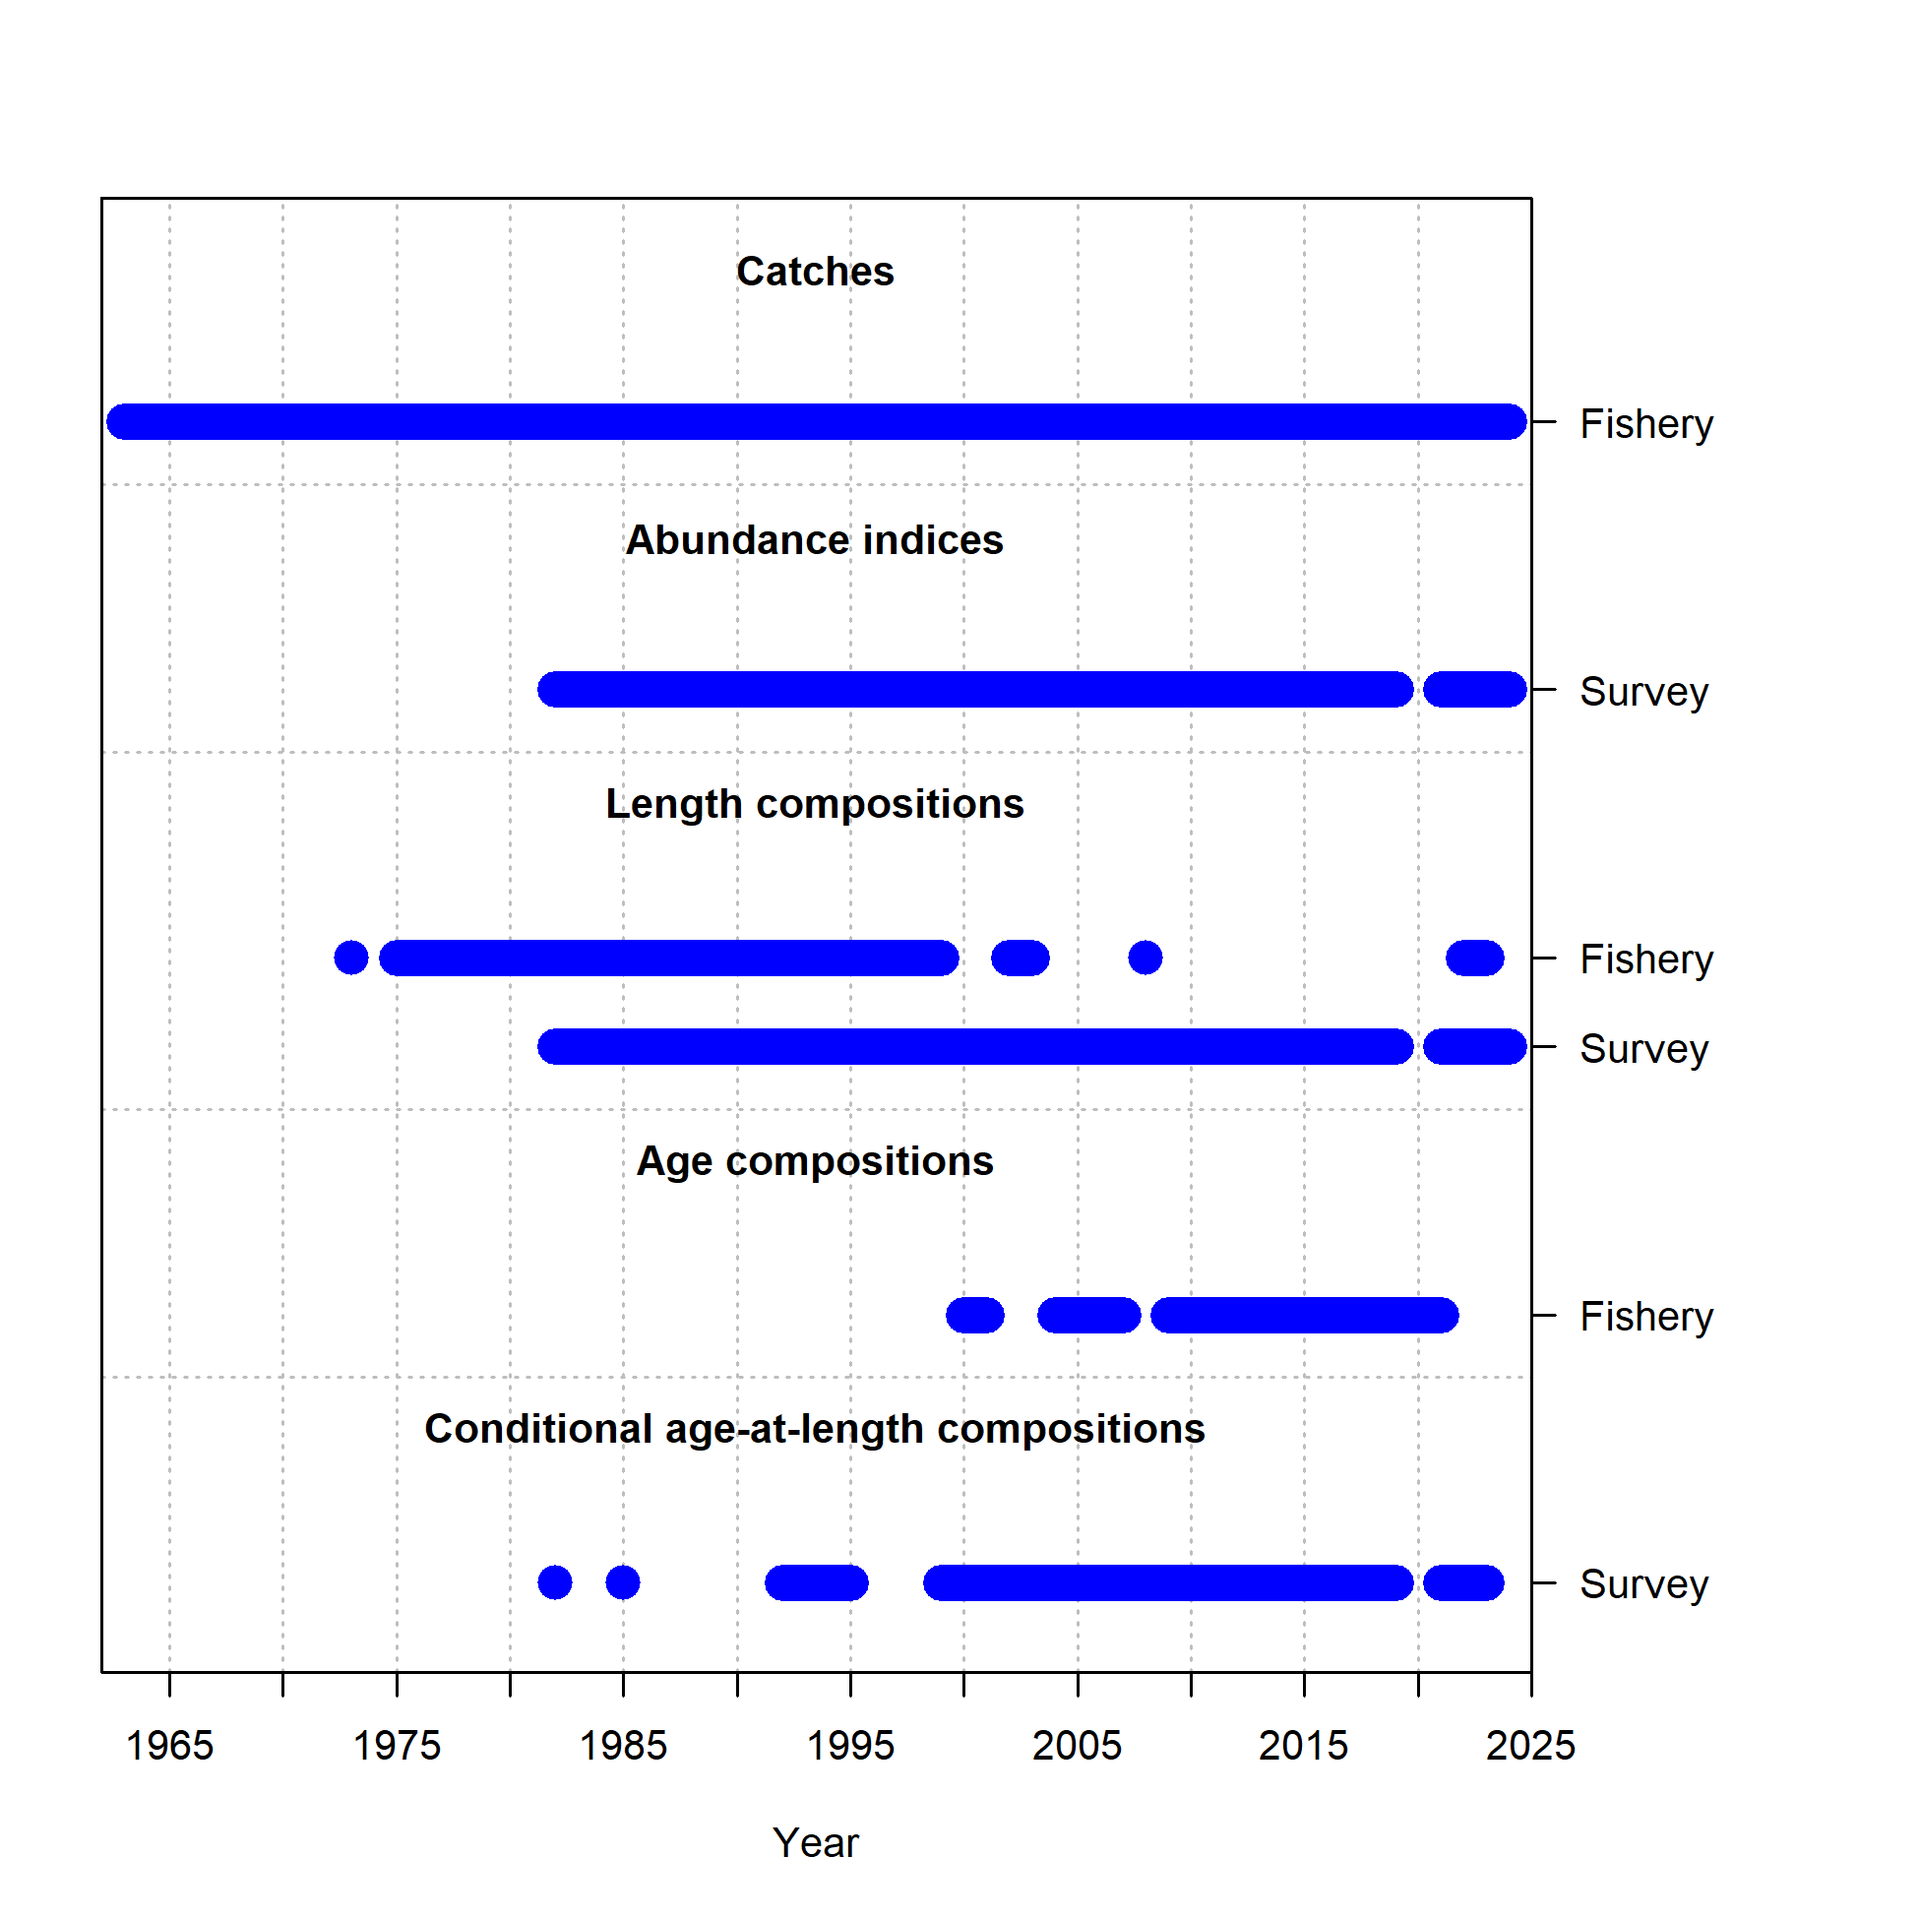

Figure 9.1. Data included in the update assessment, Model 18.2c (2024).

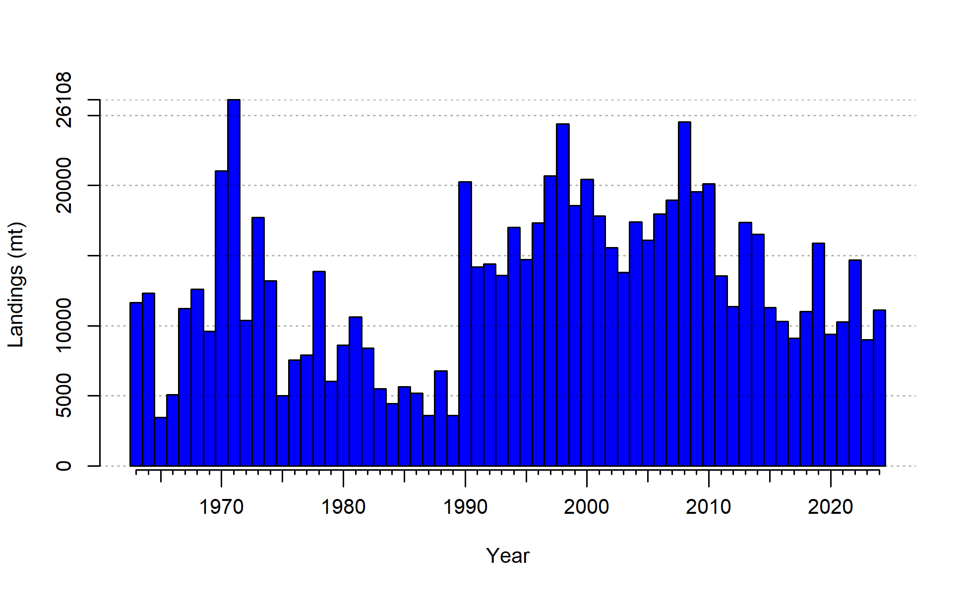

Figure 9.2. Catches for BSAI FHS used in the model; the 2024 value is extrapolated.

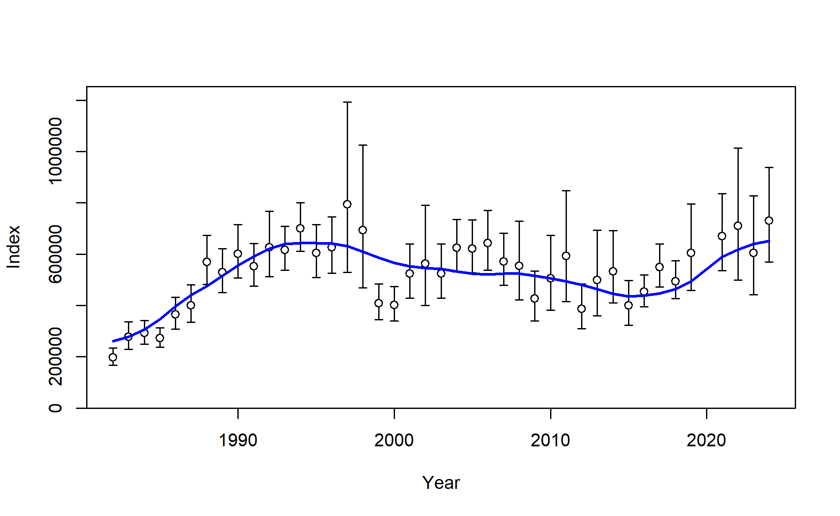

Figure 9.3. BS/AI Combined Trawl Survey observed biomass estimates with 95% sampling error confidence intervals for BSAI FHS (black points and vertical bars). Model expectations are shown in blue.

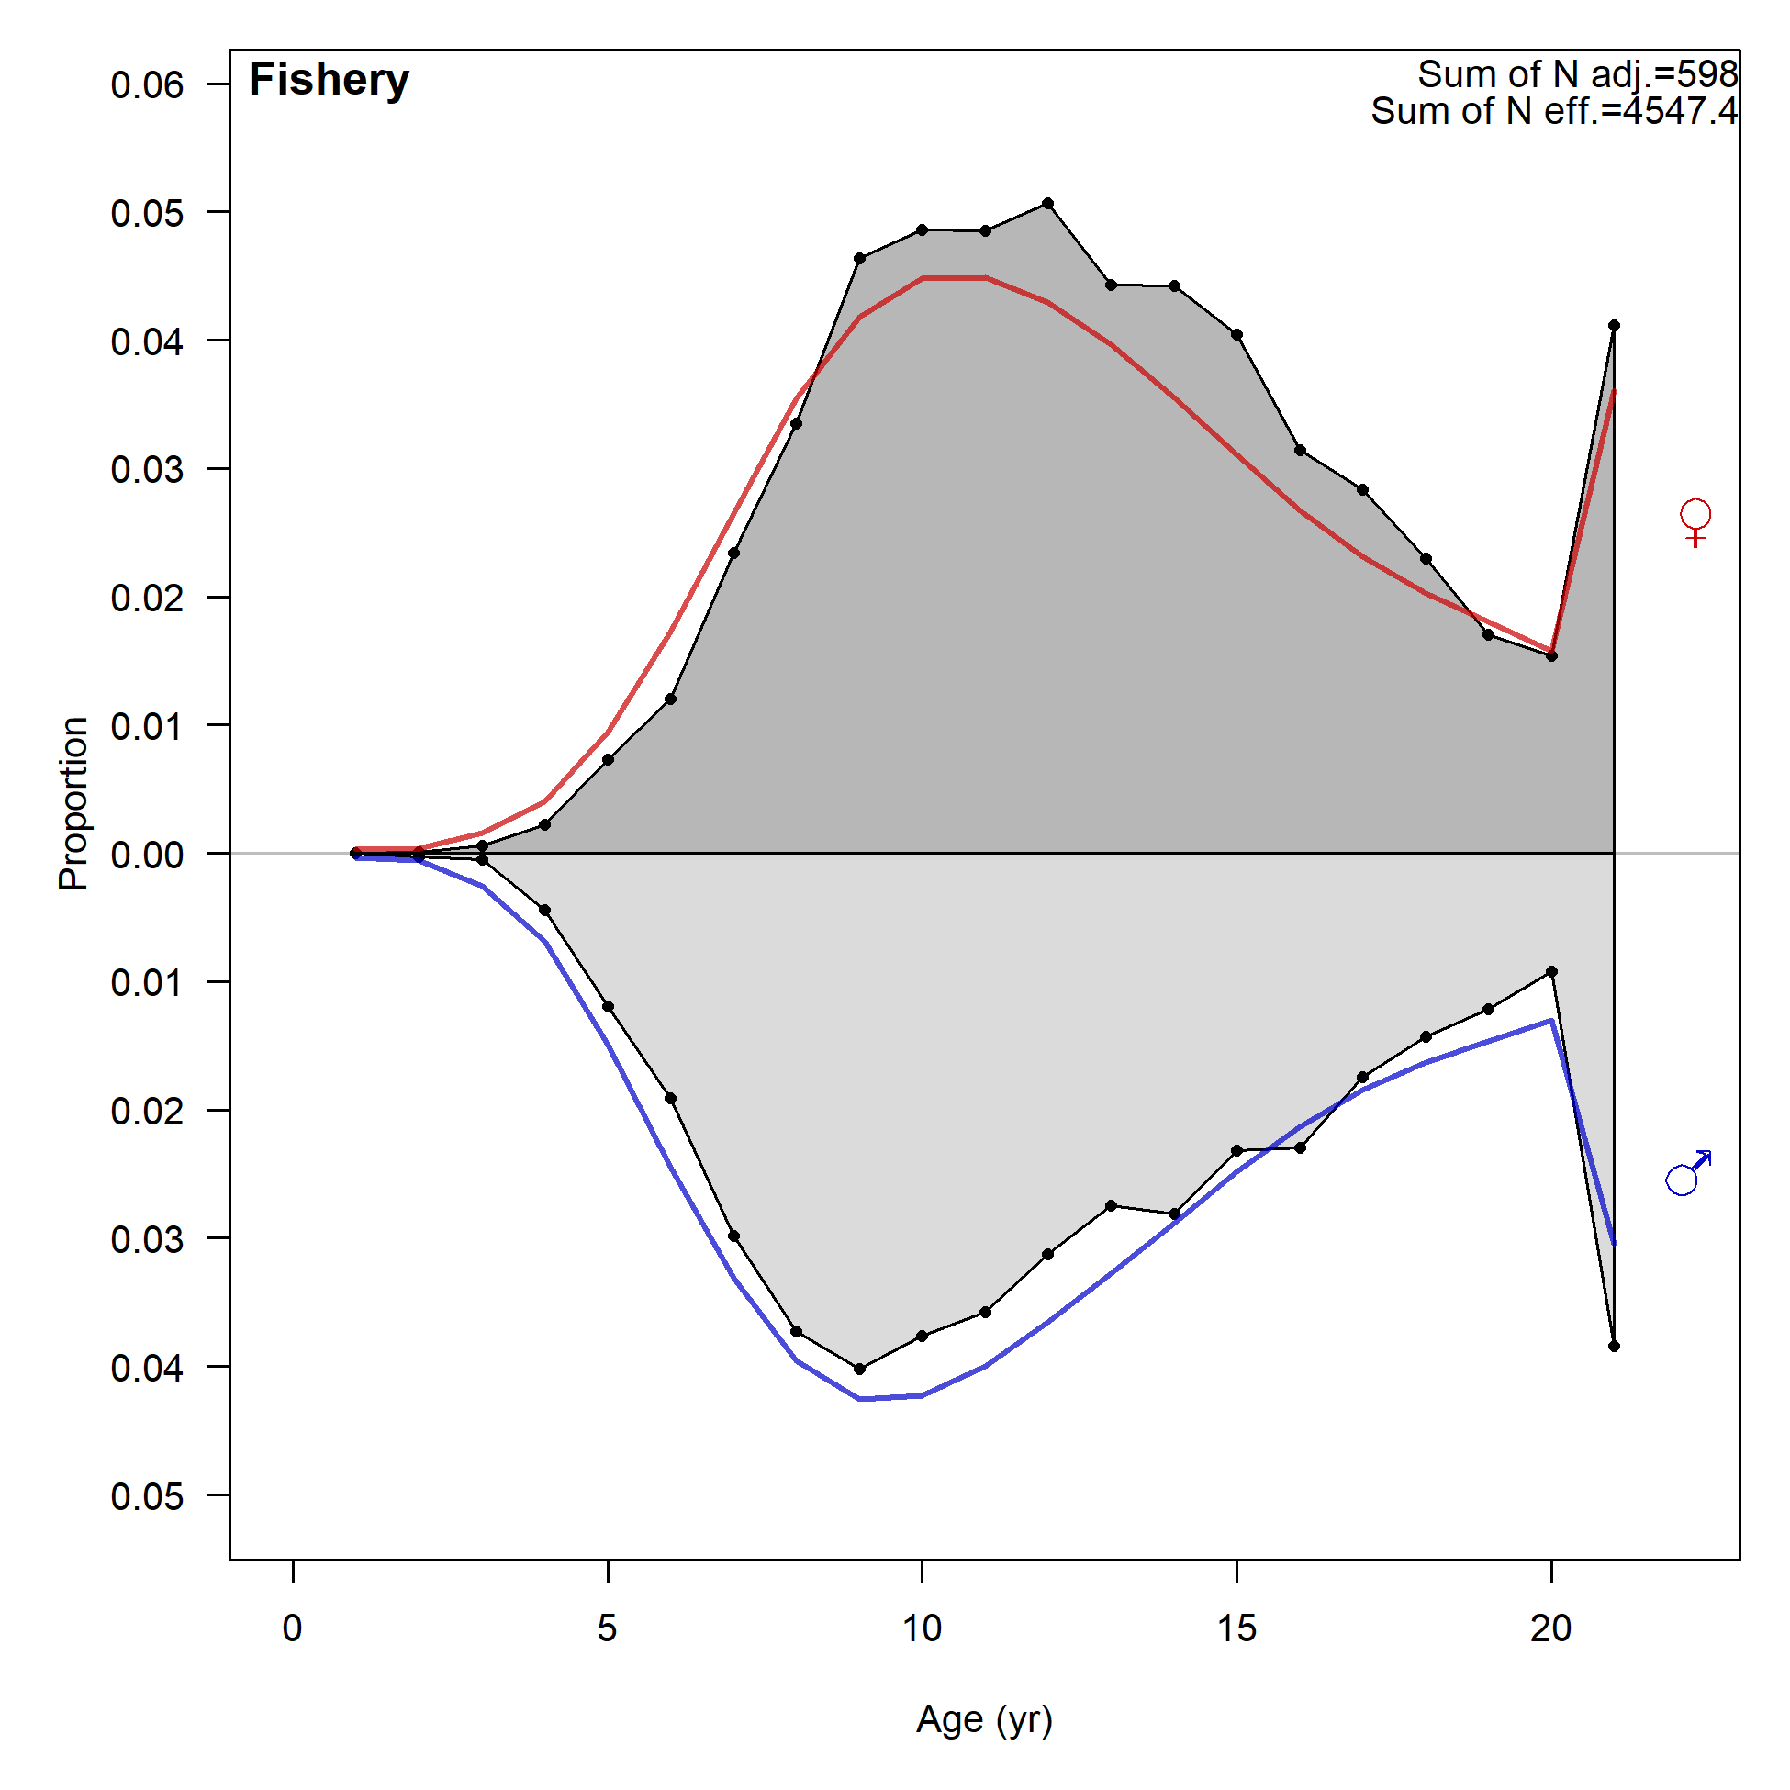

Figure 9.4. Observed (grey polygons) and predicted (colored lines) fishery age compositions for BSAI FHS, aggregated through time.

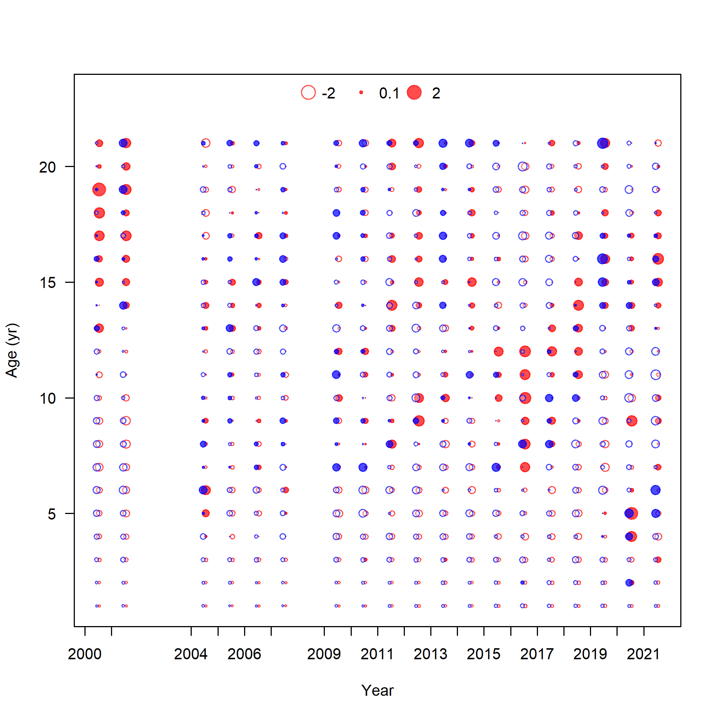

Figure 9.5. Pearson residuals for fishery and survey length compositions. Blue points are males, red points are females.

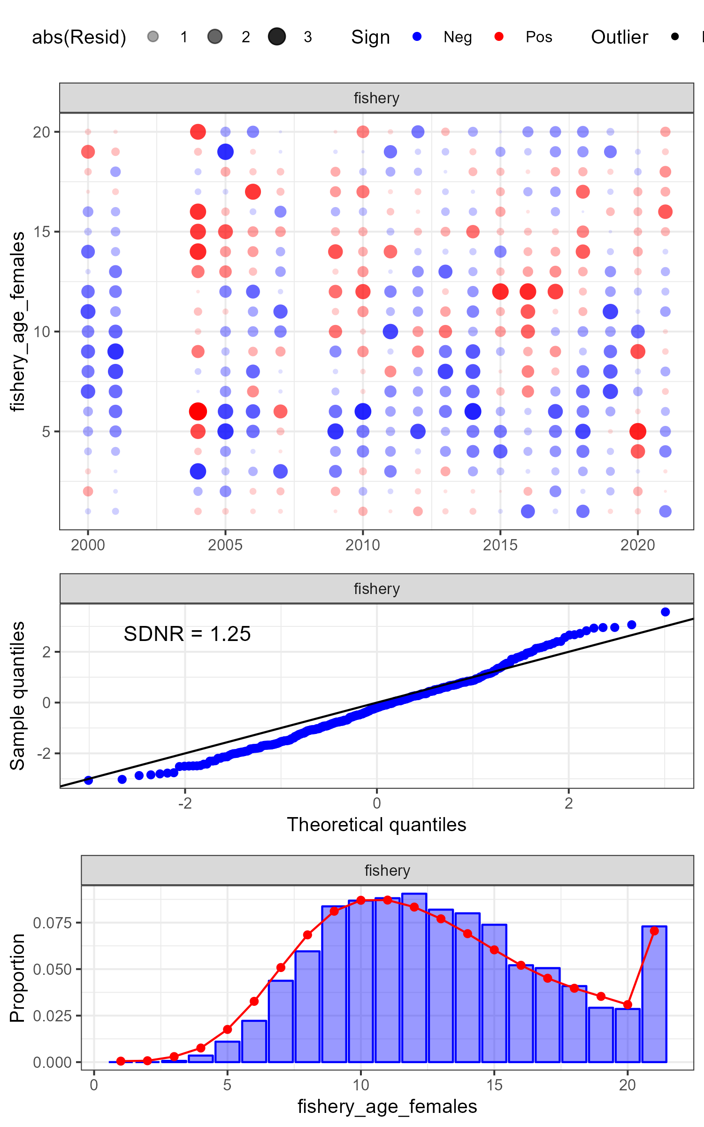

Figure 9.6. One-Step-Ahead residuals and diagnostics for female fishery age composition data.

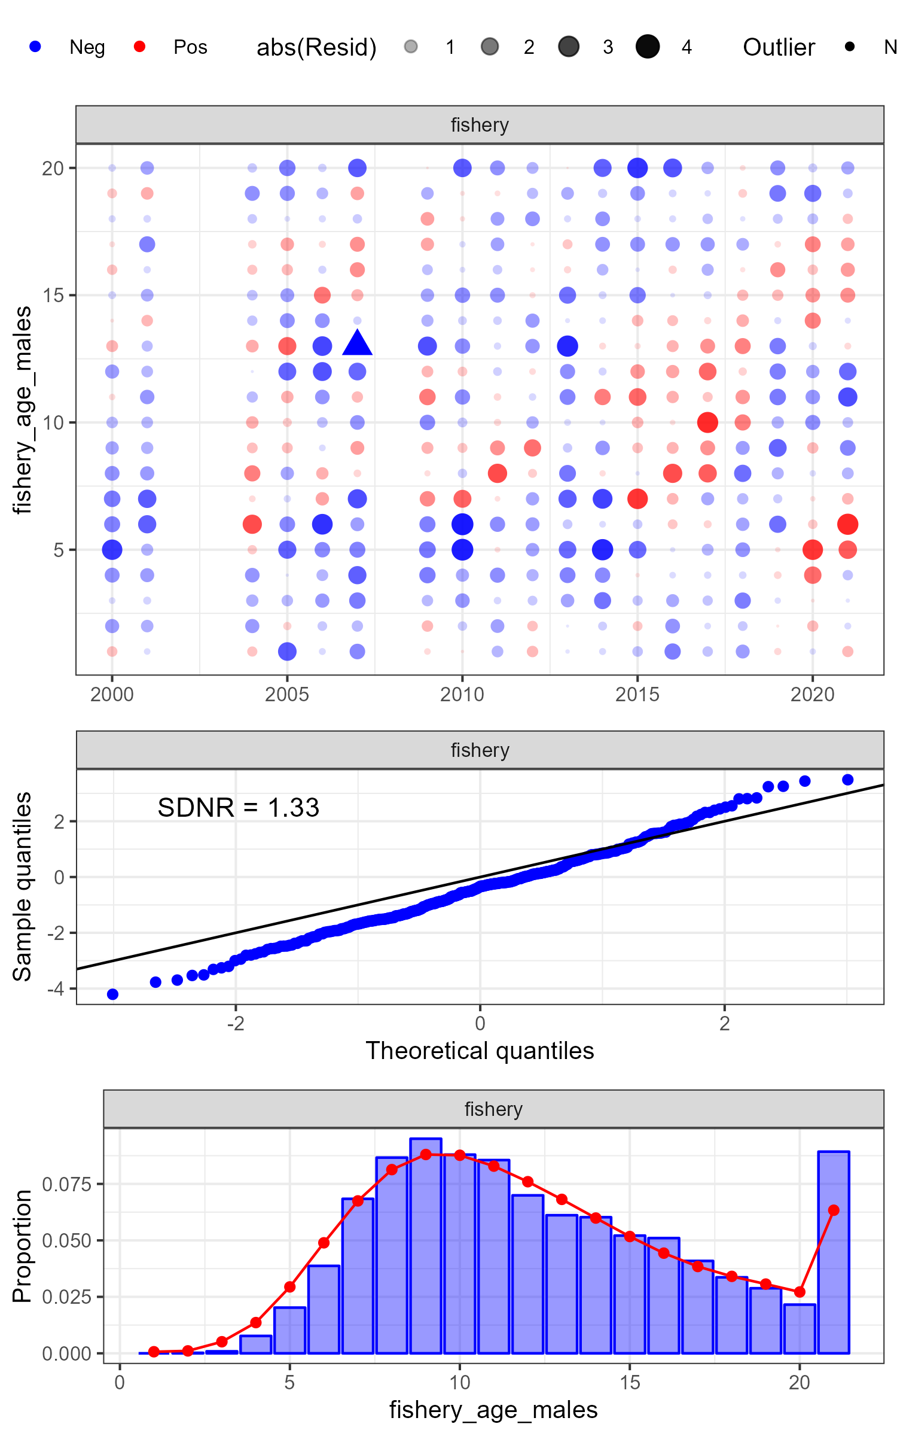

Figure 9.7. One-Step-Ahead residuals and diagnostics for male fishery age composition data.

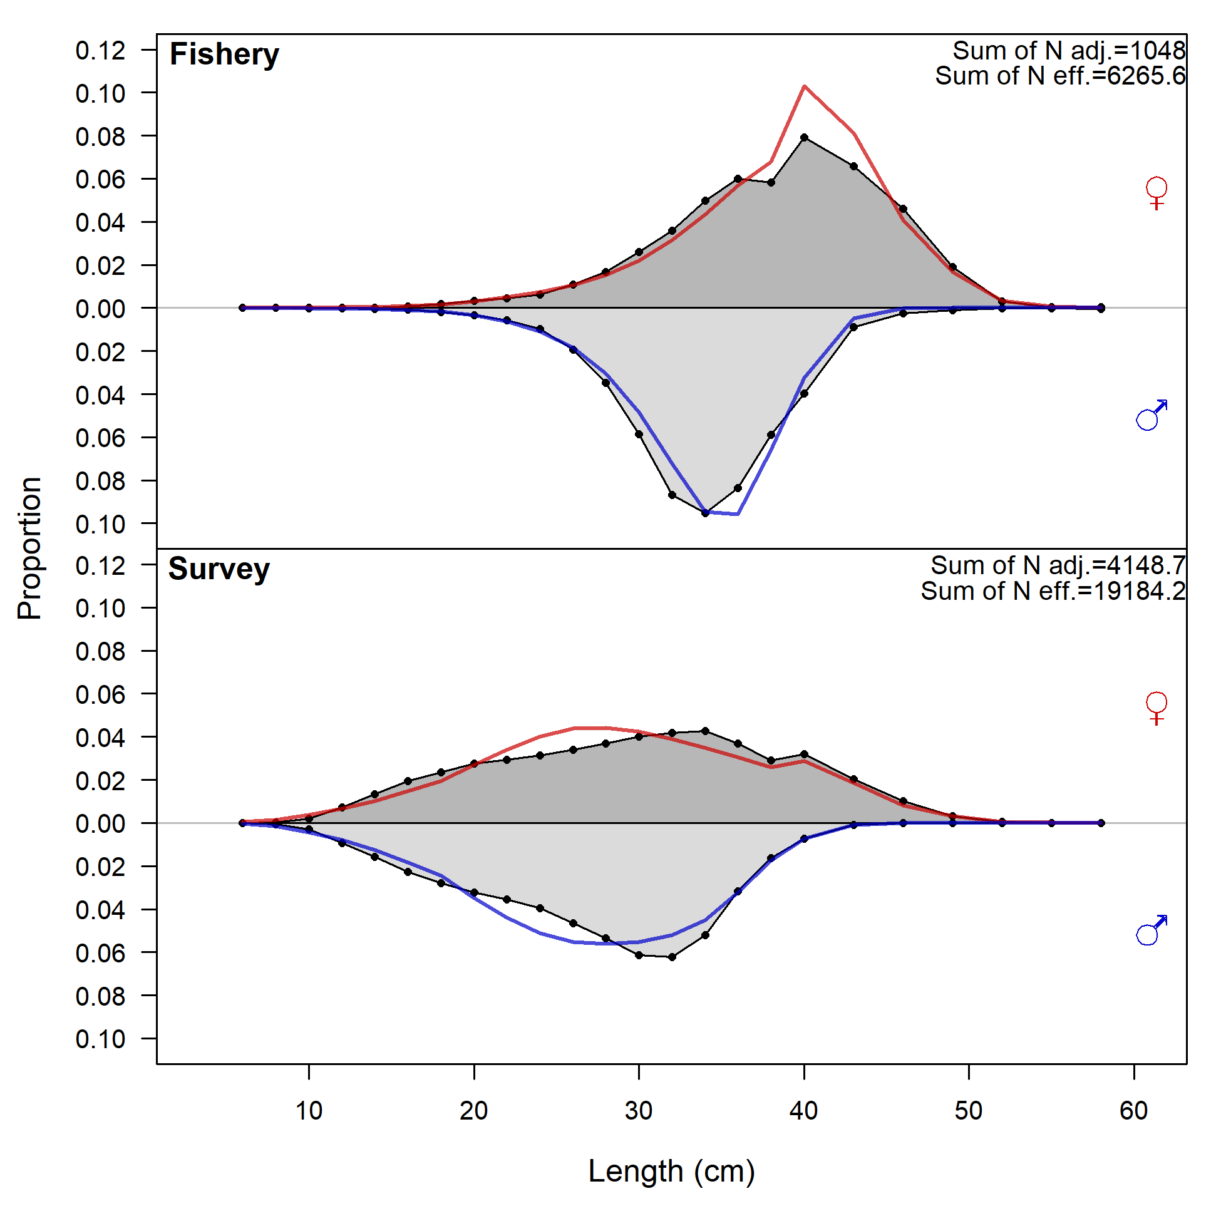

Figure 9.8. Observed (grey polygons) and predicted (colored lines) fishery and survey length (cm) compositions for BSAI FHS, aggregated through time. Note that many years of the Fishery length composition data are not included in the joint likelihood (in lieu of age compositions).

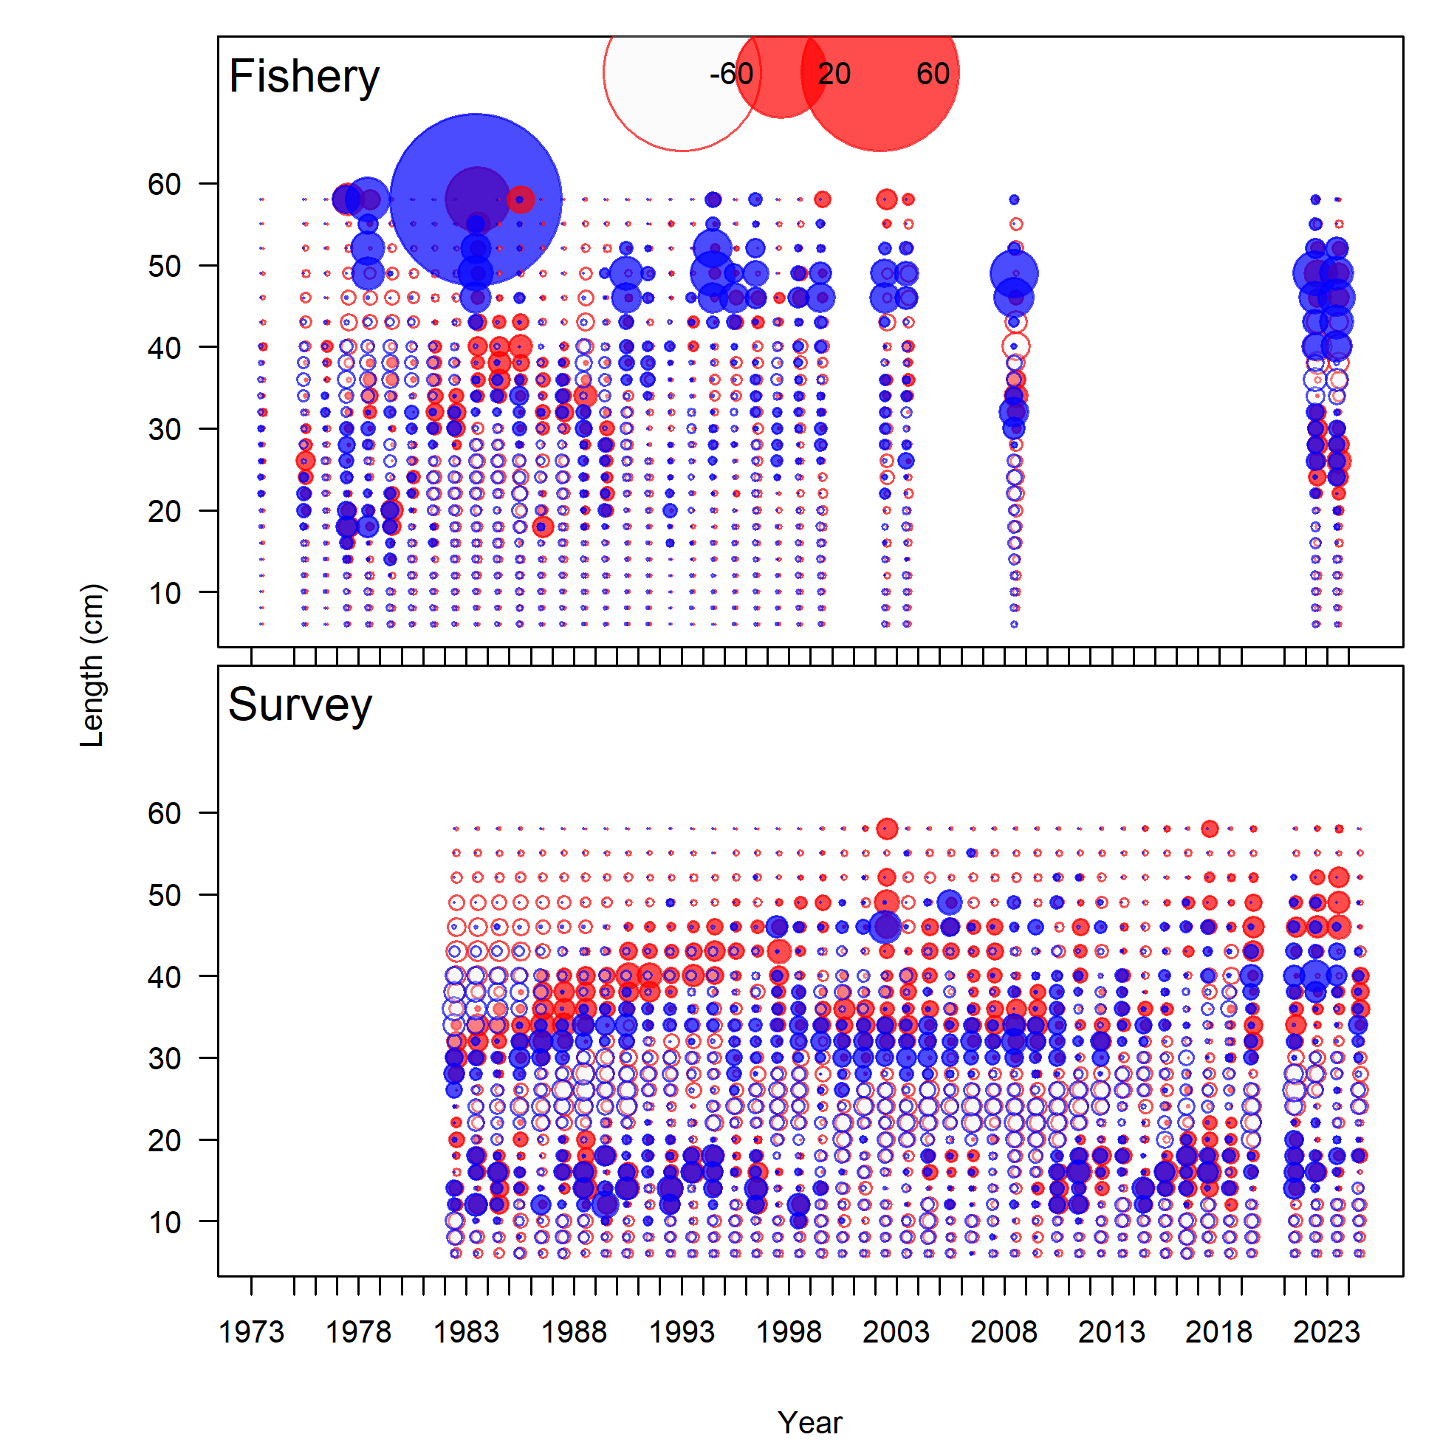

Figure 9.9. Observed (grey polygons) and predicted (colored lines) fishery age compositions for BSAI FHS, aggregated through time.

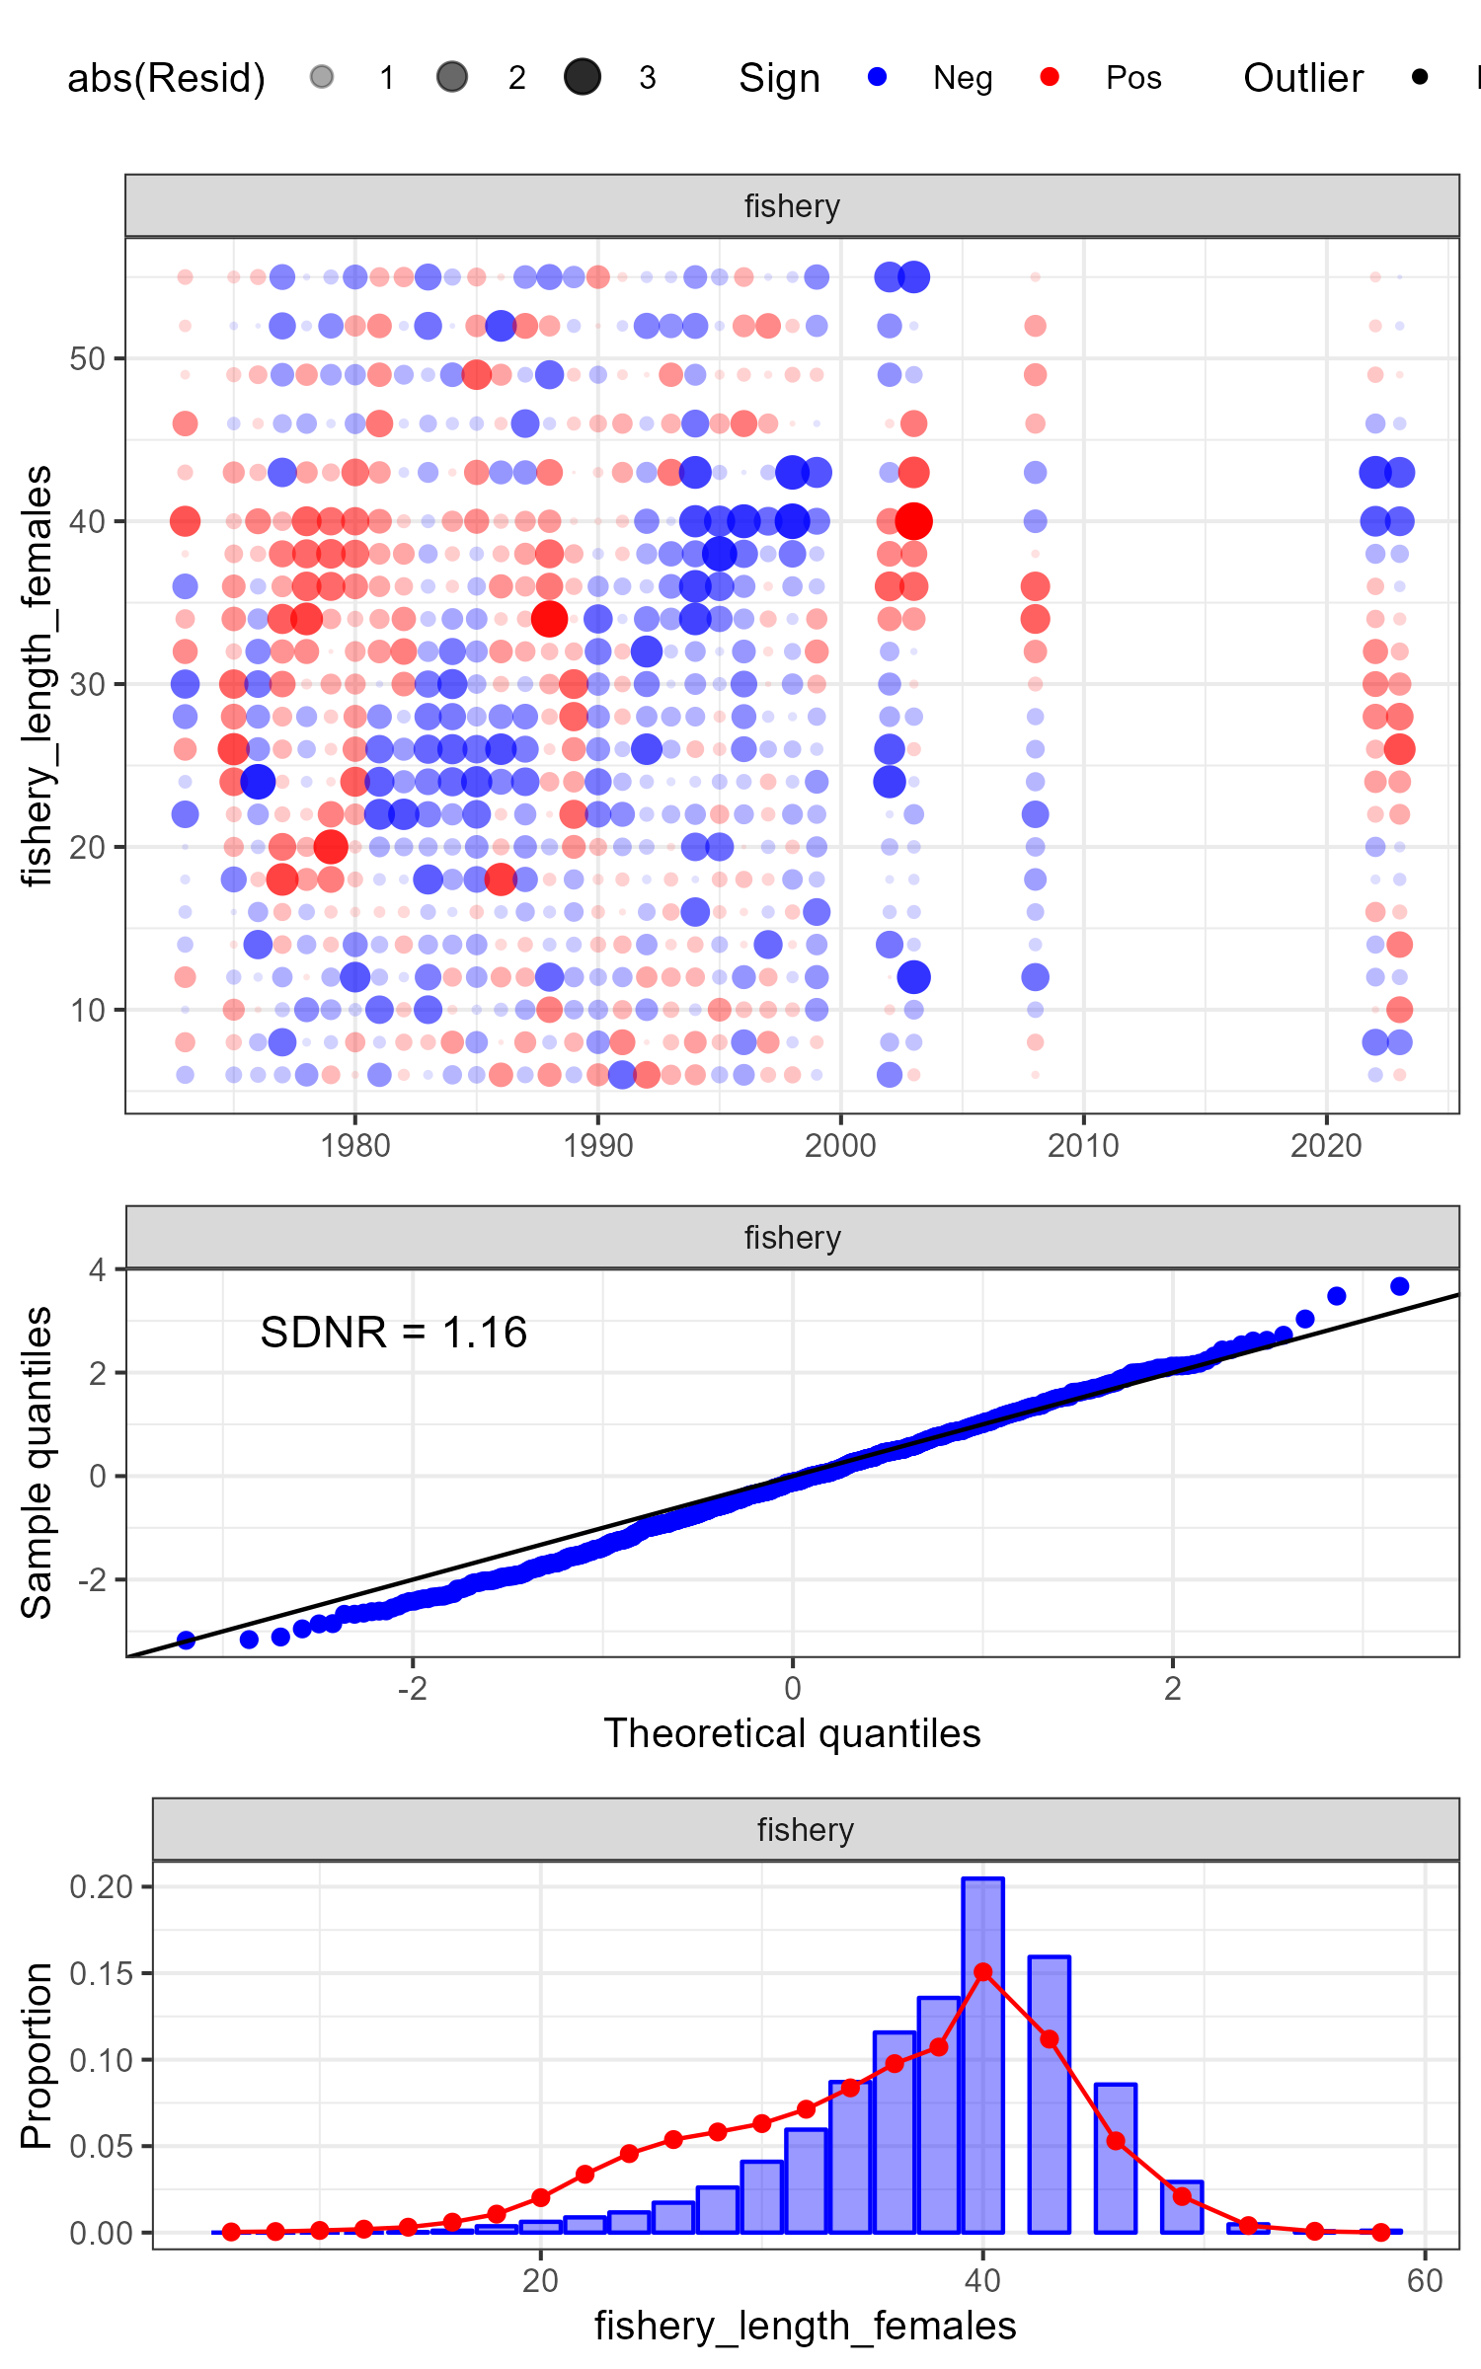

Figure 9.10. One-Step-Ahead residuals and diagnostics for female fishery length composition data.

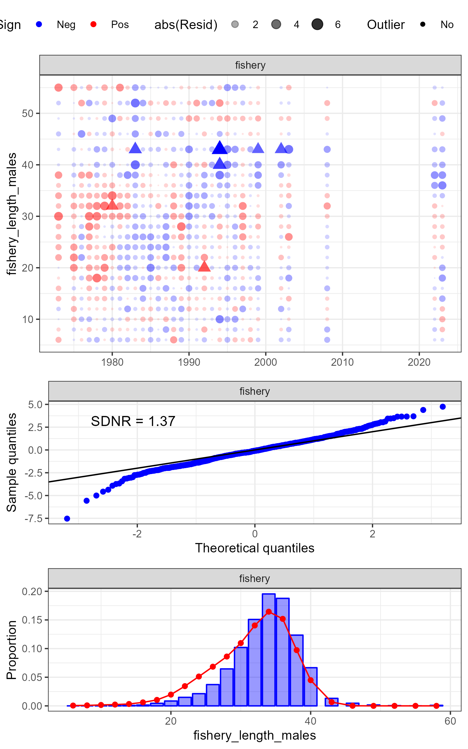

Figure 9.11. One-Step-Ahead residuals and diagnostics for male fishery length composition data.

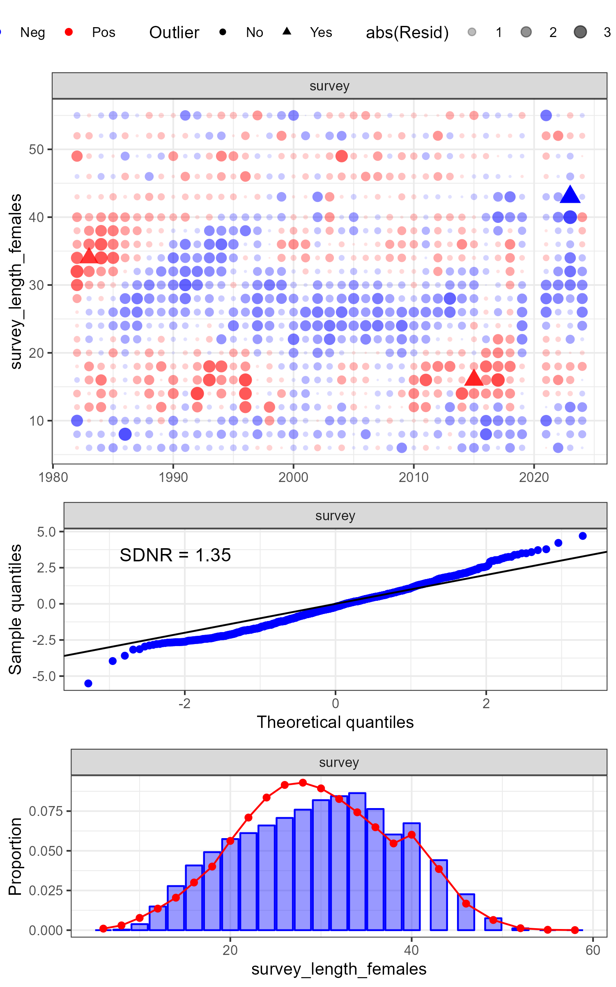

Figure 9.12. One-Step-Ahead residuals and diagnostics for female survey length composition data.

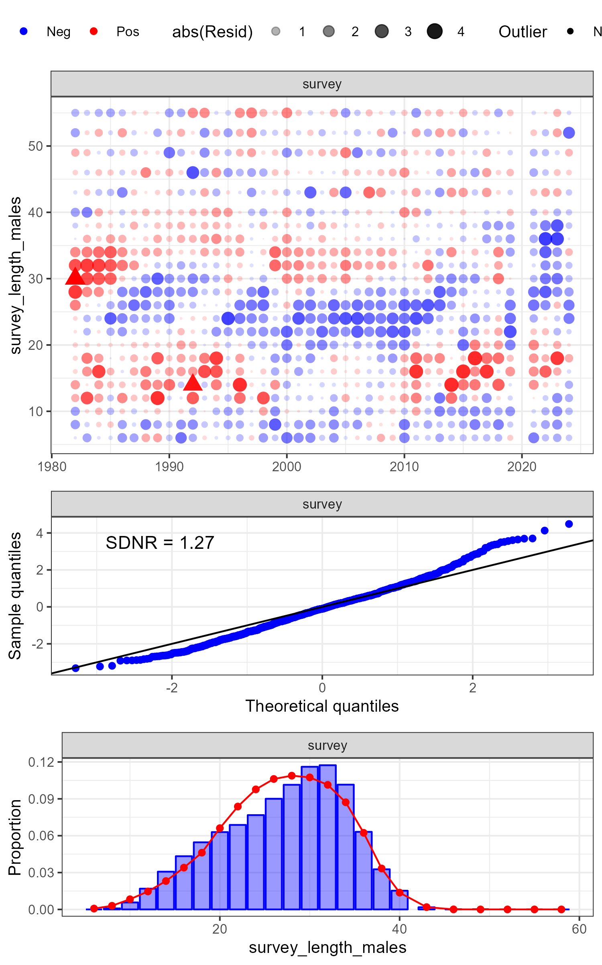

Figure 9.13. One-Step-Ahead residuals and diagnostics for male survey length composition data.

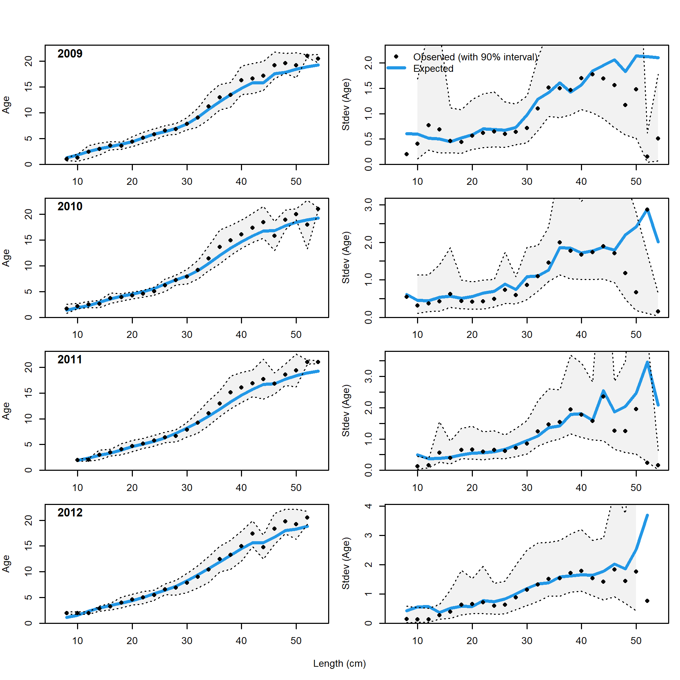

Figure 9.14. Observed and expected mean age-at-length for both females and males with 90% intervals about observed age-at-length (left panels) and observed and expected standard deviation in age-at-length (right panels) for Model 18.2c (2024) for years 2009-2012 (1 of 3).

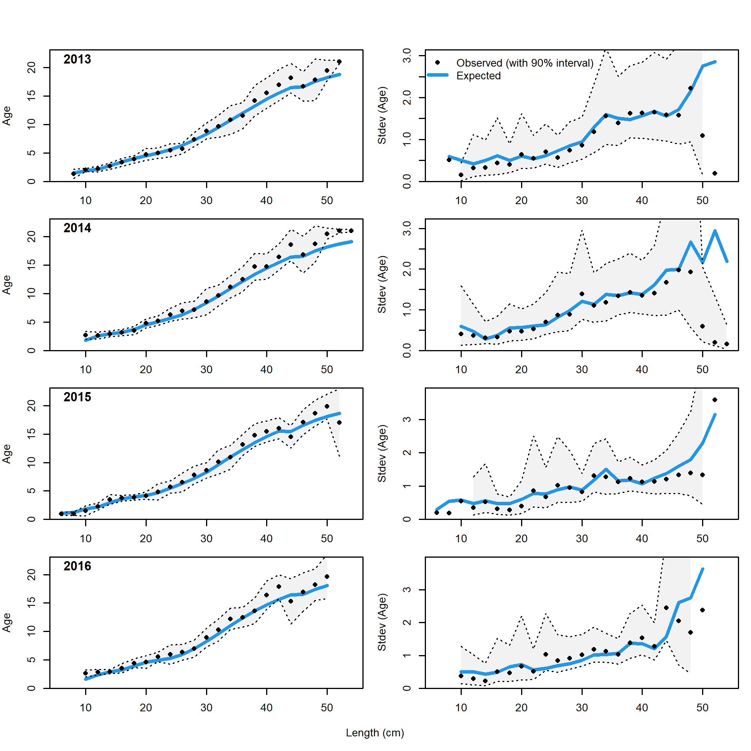

Figure 9.15. Observed and expected mean age-at-length for both females and males with 90% intervals about observed age-at-length (left panels) and observed and expected standard deviation in age-at-length (right panels) for Model 18.2c (2024) for years 2013-2016 (2 of 3).

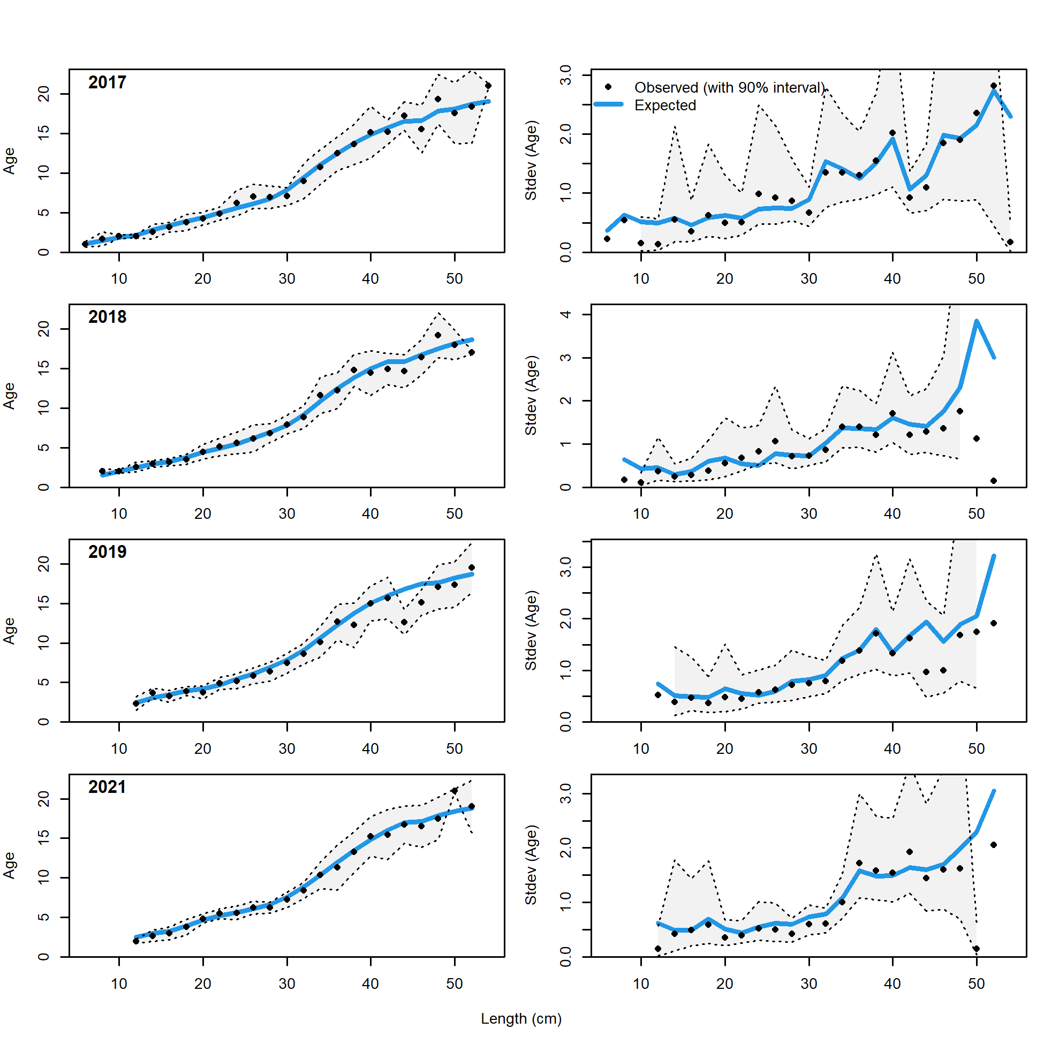

Figure 9.16. Observed and expected mean age-at-length for both females and males with 90% intervals about observed age-at-length (left panels) and observed and expected standard deviation in age-at-length (right panels) for Model 18.2c (2024) for years 2017-2021 (3 of 3).

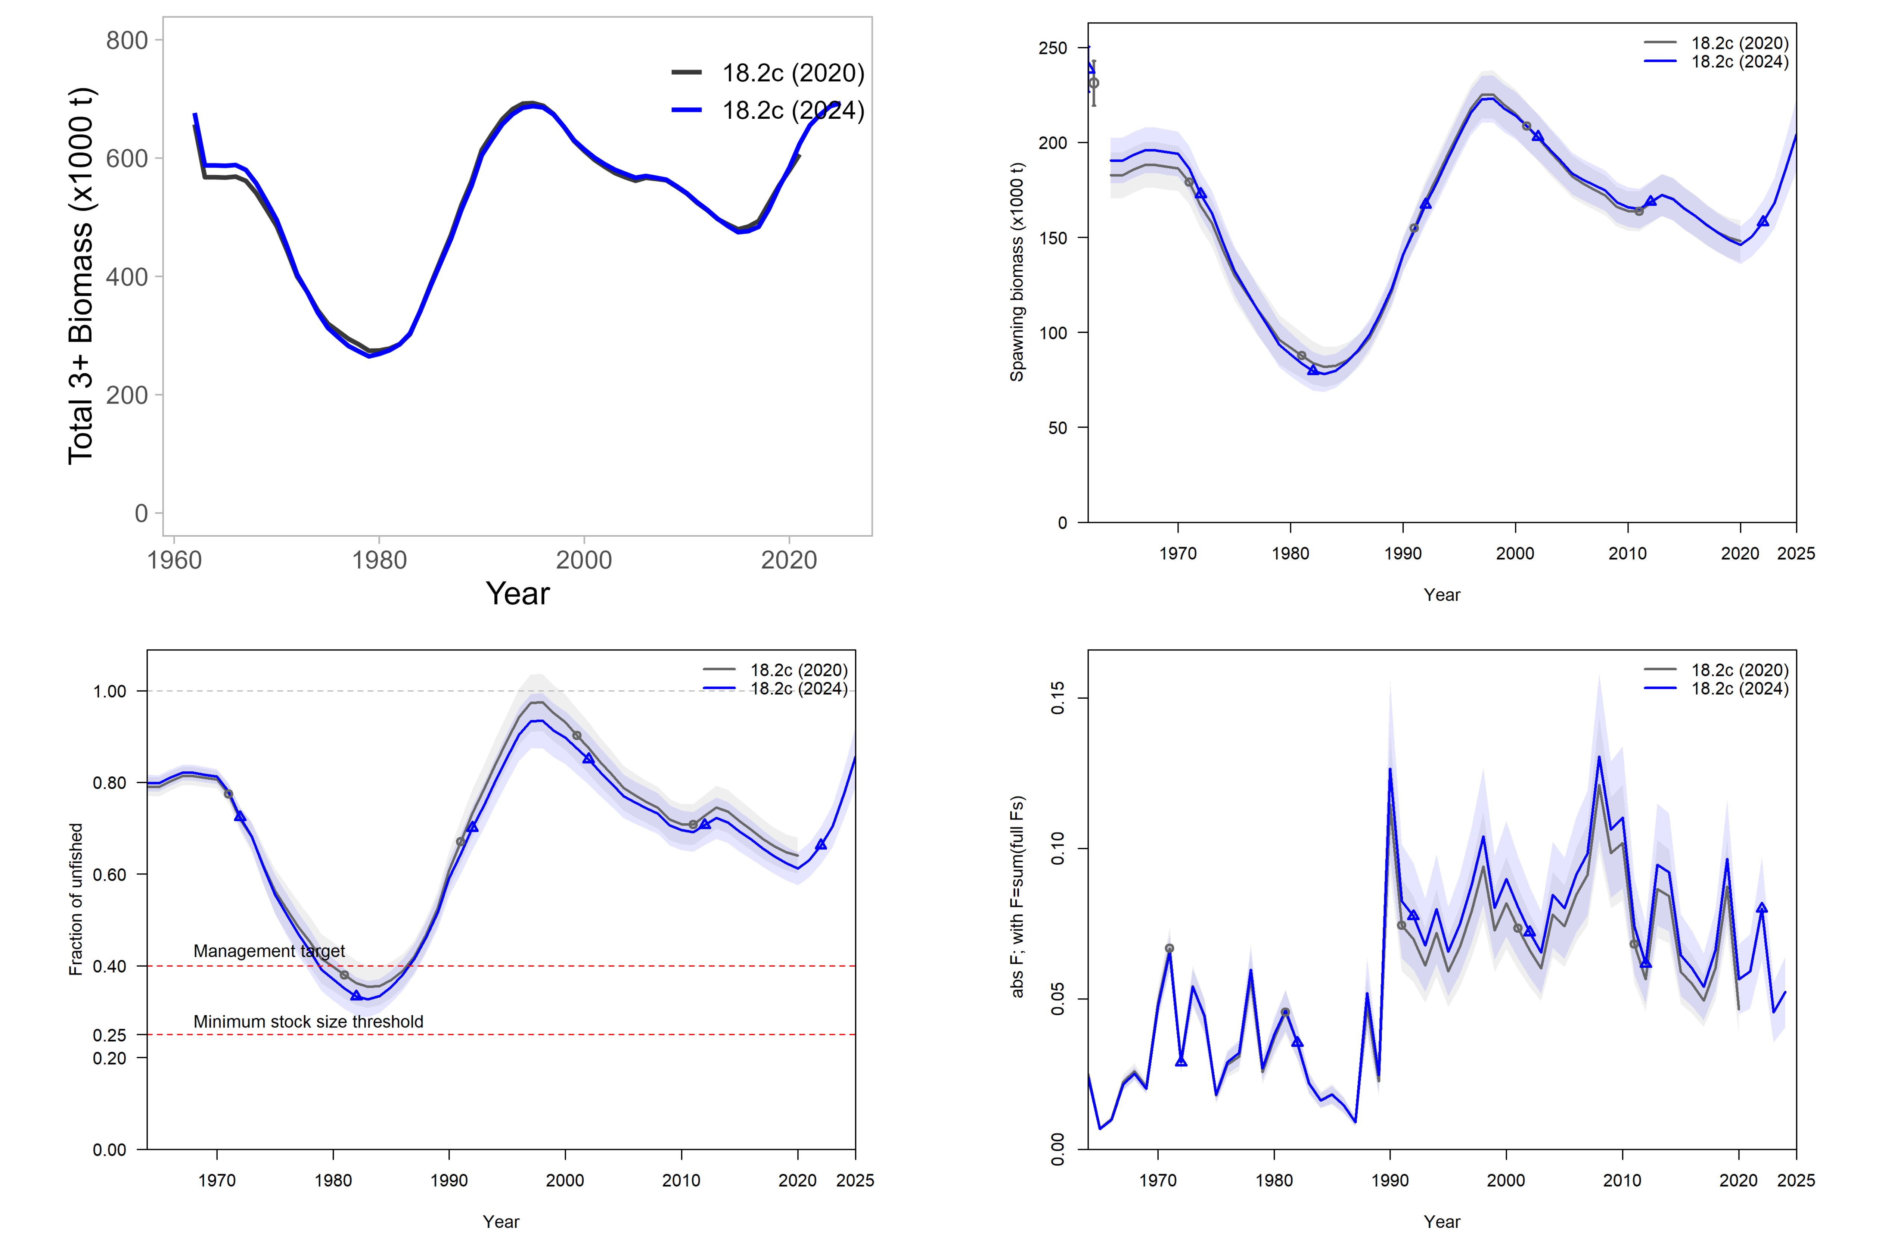

Figure 9.17. Comparison of spawning biomass, fishing mortality rates, and recruitment for the 2024 Update model (blue) and 2020 Full model (grey). The shaded ribbon represents the 95% quantile. Uncertainty intervals not available for total biomass.

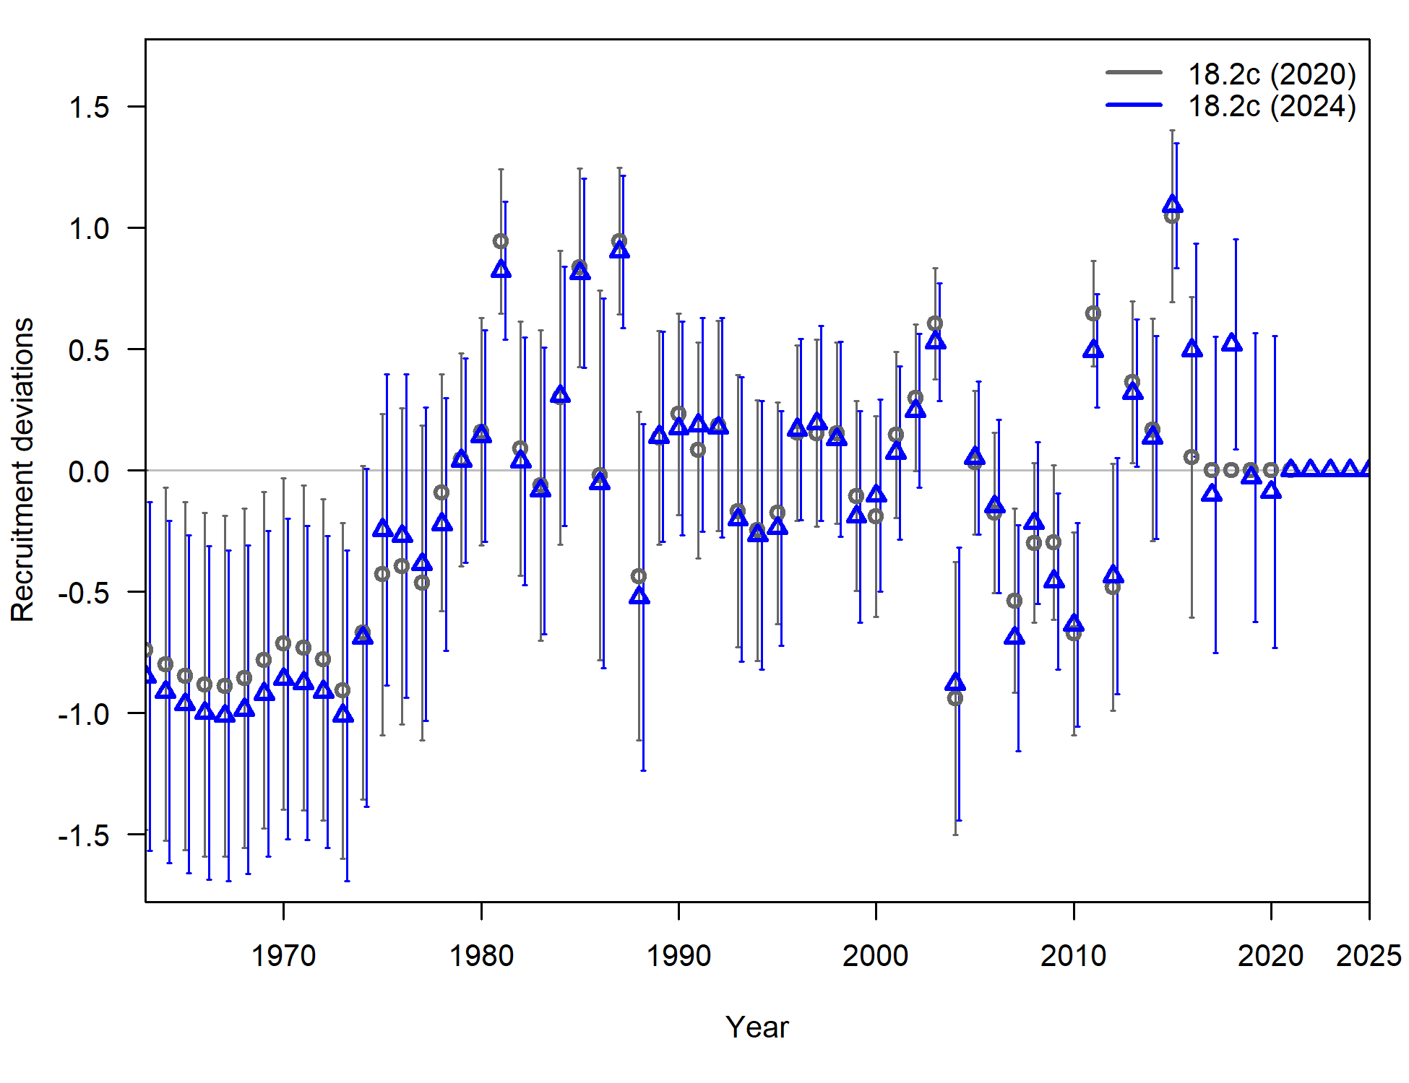

Figure 9.18. Time series of recruitment deviations, from the 2024 base model (blue) and 2021 base model (grey), with 95% intervals.

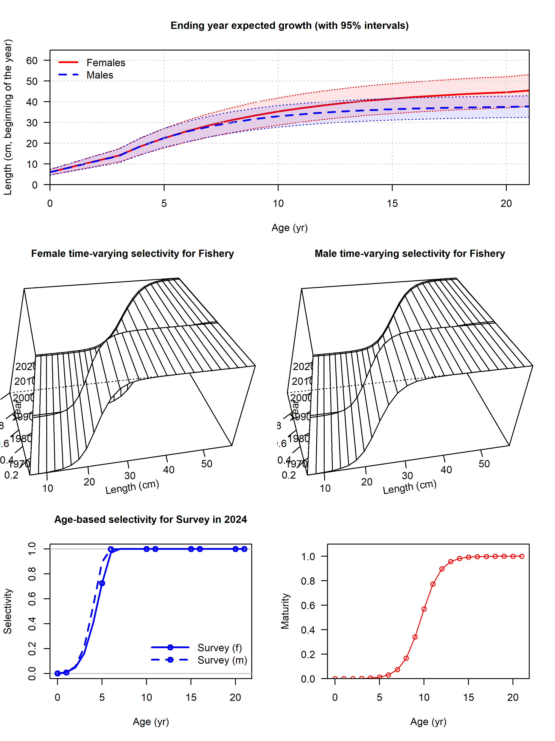

Figure 9.19. Estimated growth curves; time-varying, length-based fishery selectivity; age-based survey selectivity; and female maturity-at-age.

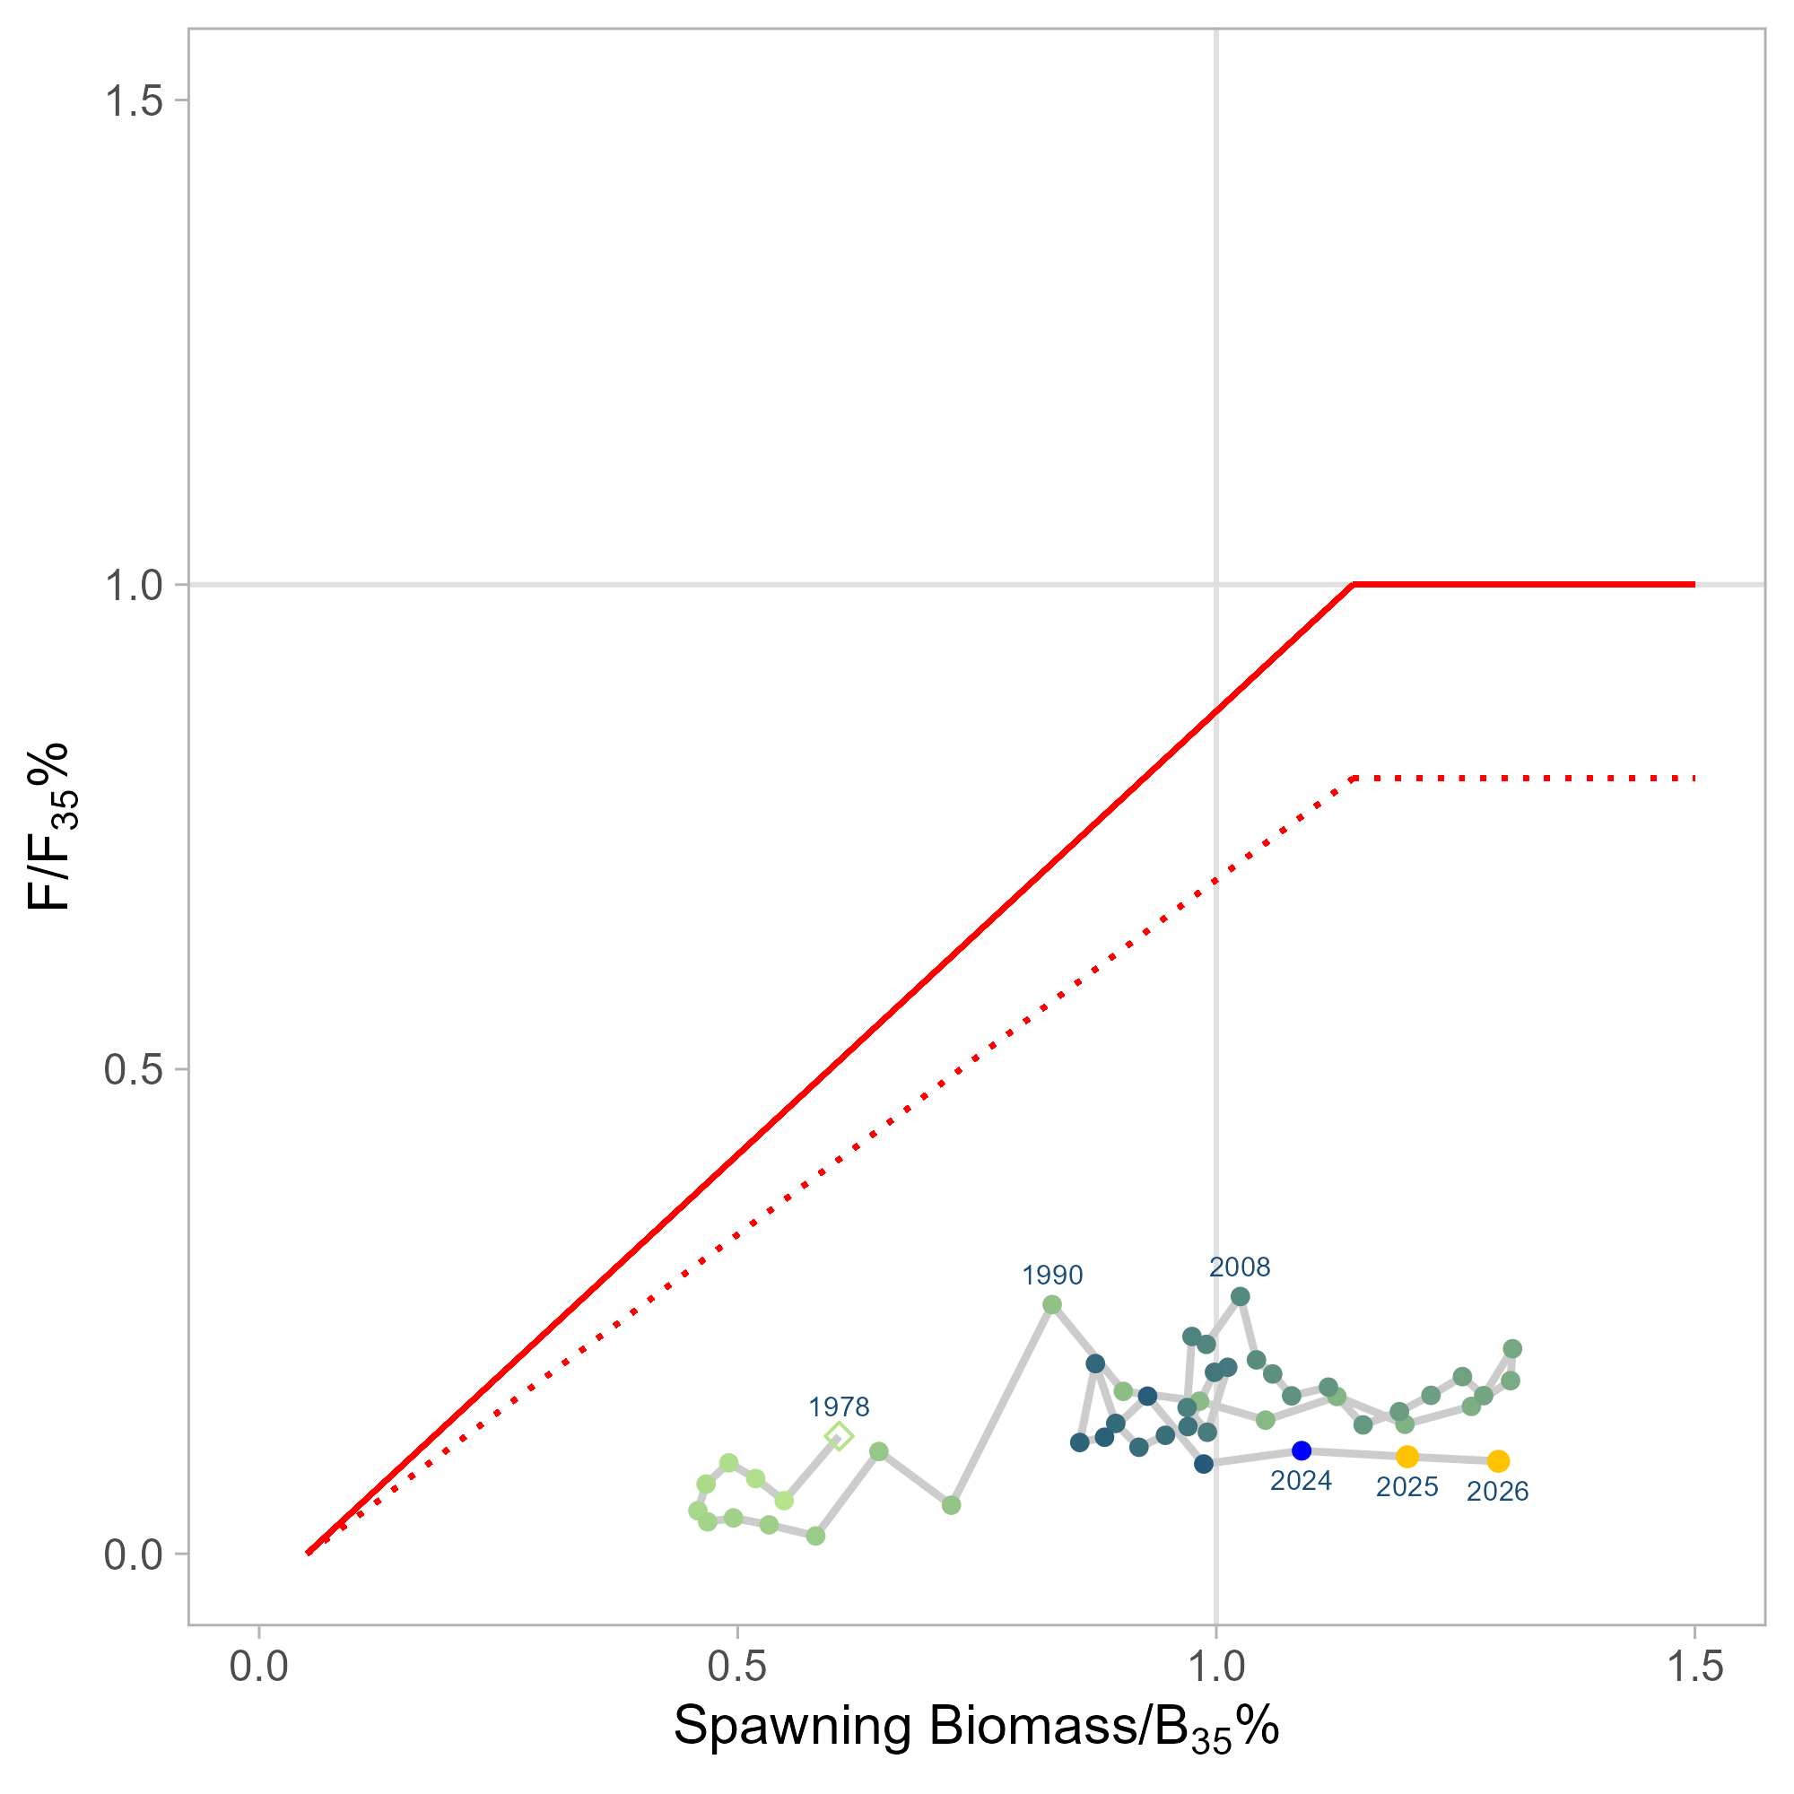

Figure 9.20. Time series of estimated fishing mortality versus estimated spawning stock biomass (phase-plane plot) for 1978-2026, including applicable OFL and maximum FABC definitions for the stock, including 2 years of projected values. Target levels correspond to B35% and F35% for author recommended model.

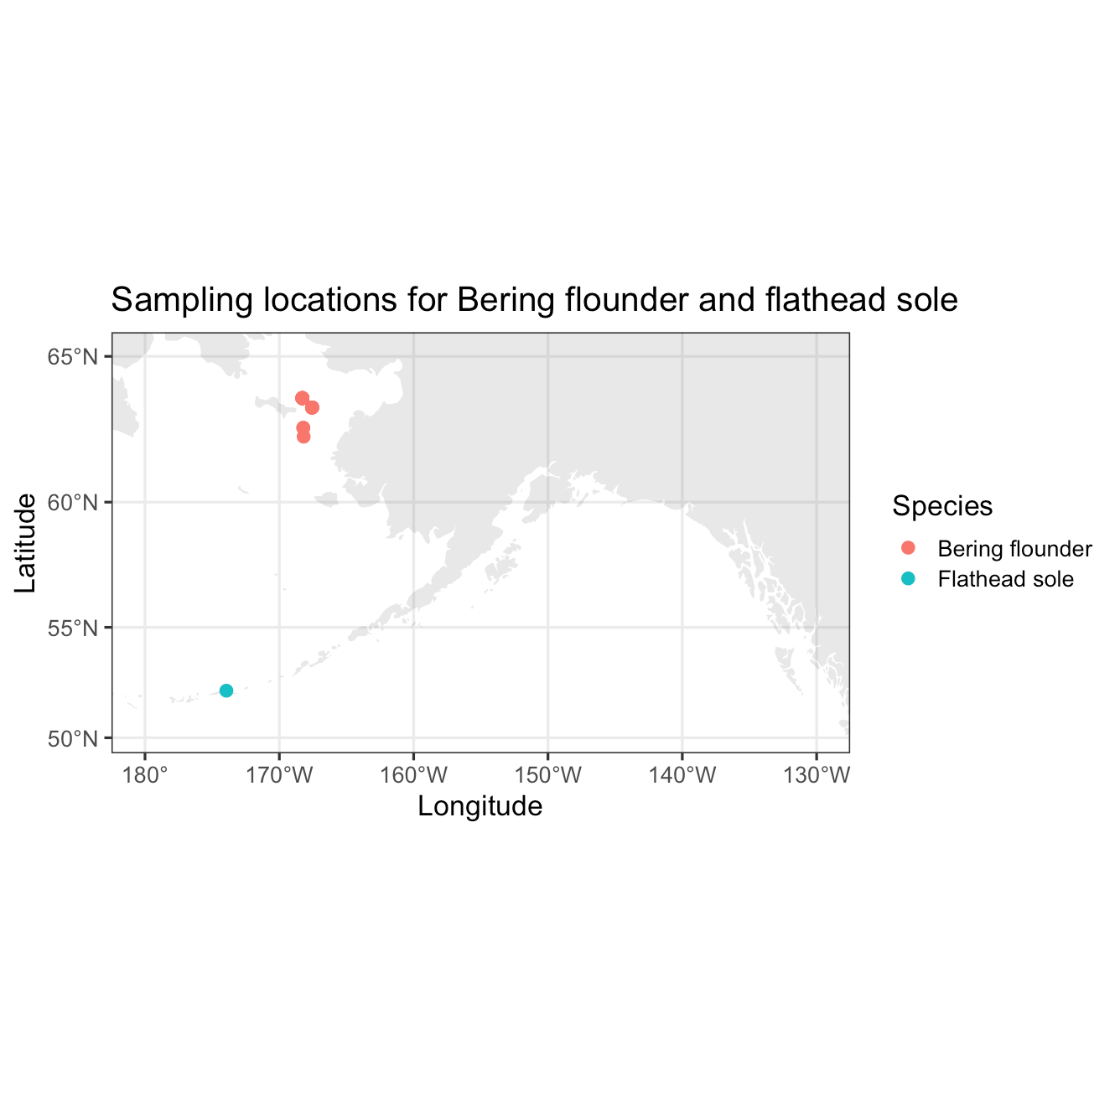

Figure 9.21. Collection locations of Bering flounder (n=23) and flathead sole (n=24) sequenced using low coverage whole genome sequencing.

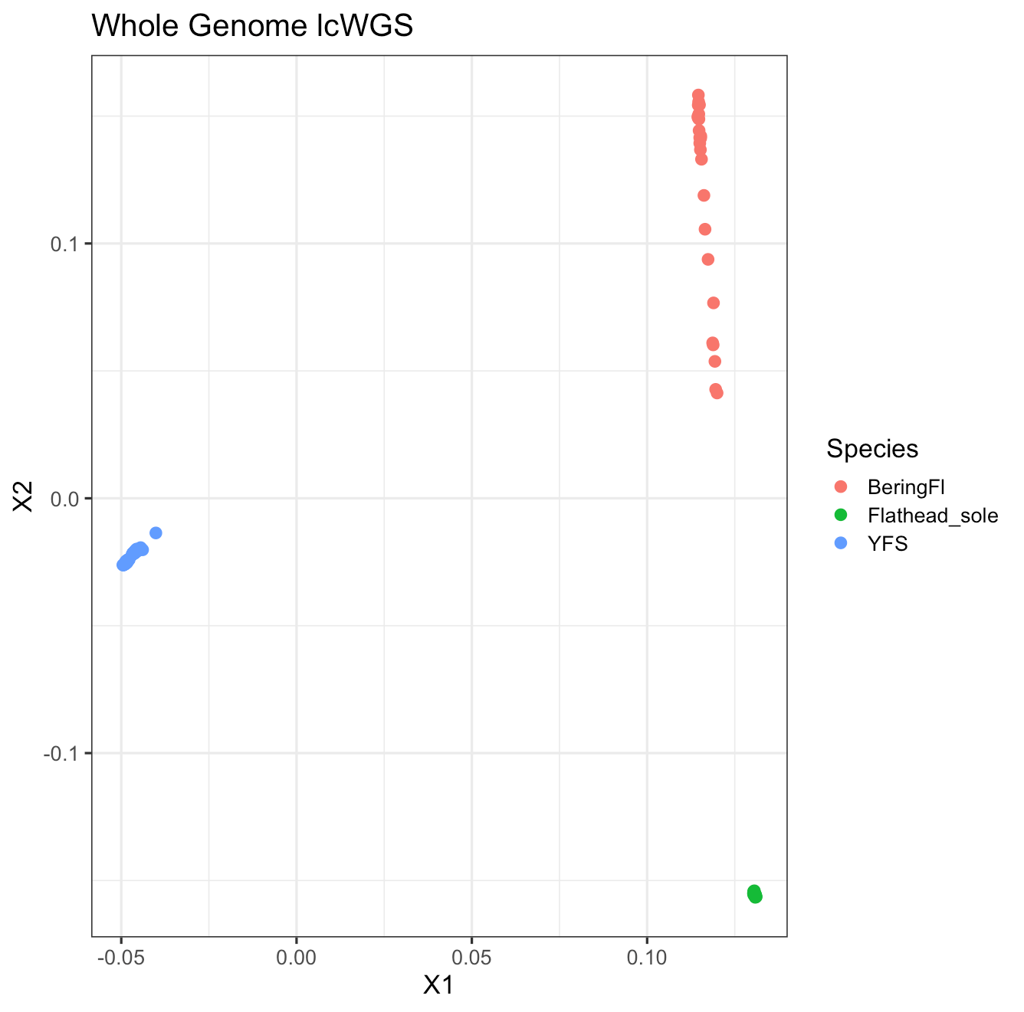

Figure 9.22. . Principal components analysis of yellowfin sole (YFS), Bering flounder, and flathead sole, first and second principal components axes. .